**An Optimized Artificial Intelligence Enabled Sentiment Analysis on the COVID-19 Pandemic**

**A Project Work Report**

*Submitted in the partial fulfilment for the award of the degree of*

**BACHELOR OF ENGINEERING**

**IN**

**COMPUTER SCIENCE WITH SPECIALIZATION IN**

**ARTIFICIAL INTELLIGENCE AND MACHINE LEARNING**

**Submitted by:**

Ayush Kumar Jha:20BCS3985

Bharat Yadav:20BCS6901

Mohit Choudhary:21BCS10085

Shyam Prakash Mishra:20BCS6893

**Under the Supervision of:**

Siddharth Kumar



**CHANDIGARH UNIVERSITY, GHARUAN, MOHALI - 140413,**

**May 2023**

**Declaration**

We, students of **‘Bachelor of Engineering in CSE-AIML’**, 6th Semester **session: Feb-May 2023**, Department of Computer Science and Engineering, Apex Institute of Technology, Chandigarh University, Punjab, hereby declare that the work presented in this Project Work entitled **‘An Optimized Artificial Intelligence Enabled Sentiment Analysis on the COVID-19 Pandemic’** is the outcome of our own bona fide work and is correct to the best of our knowledge and this work has been undertaken taking care of Engineering Ethics. It contains no material previously published or written by another person nor material which has been accepted for the award of any other degree or diploma of the university or other institute of higher learning, except where due acknowledgment has been made in the text.

|  |  |  |  |
| --- | --- | --- | --- |
| Table of Contents  |  |  | | --- | --- | | Title Page | 1 |   Abstract |  |
| 1.    Introduction | 4 |
| 1.1           Problem Definition | 7 |
| 1.2 Project Overview | 7 |
| 1.3 Hardware Specification | 8 |
| 1.4 Software Specification | 8 |
| 2.    Literature Survey | 9 |
| 2.1 Existing System | 9 |
| 2.2 Proposed System | 10 |
| 2.3 Literature Review Summary | 11 |
| 3.    Problem Formulation | 12 |
| 4.    Research Objective | 13 |
| 5.    Methodologies | 15 |
| 6.    Experimental Setup | 16 |
| 7.    Conclusion | 62 |
| 8.    Tentative Chapter Plan for the proposed work | 65 |
| 9.    Reference | 66 |

**INTRODUCTION**

A novel coronavirus disease 19, also referred to as COVID-19, is an infectious disease caused by severe respiratory syndrome coronavirus type 2 (SARS-CoV-2). The most common symptoms experienced by COVID-19 infected patients are dry cough, loss of smell and taste, fever, fatigue, and respiratory illness such as shortness of breath.

To control and mitigate the transmission of the novel virus, many countries have announced lockdowns and curfews with immediate effect. Paramedical staff, scientists, and researchers started working day and night to search for new technologies to mitigate the COVID-19 pandemic as a short-term strategy and started research on making a vaccine as an antidote for the virus as a long-term strategy.

Recent studies have shown that artificial intelligence (AI) is a promising technology that can be employed in various sectors such as, in process industries, the agriculture sector, banking, computing, and healthcare. Artificial intelligence-based tools, particularly deep learning models, are the promising techniques used to assist radiologists in the early screening of coronavirus. Moreover, it reduces the workload of the radiologists, improves detection more accurately and efficiently, gives a timely response and accurate treatment for the patients of COVID-19.

Various applications of AI to combat the COVID-19 outbreak include virus identification, screening, and diagnostics, drug repurposing or repositioning, prediction and forecasting.

# Abstract

Artificial Intelligence (AI) is the ability of a machine to perform cognitive functions of perceiving, reasoning, learning and problem-solving which humans can perform at ease. AI has gained traction since the past two decades across the globe due to the availability of a huge volume of data generated through the Internet. There has been a huge benefit to governments and businesses by processing this data using advanced algorithms in the recent past.

The COVID-19 pandemic has had a profound impact on global health, economics, and society, and has resulted in widespread anxiety, fear, and uncertainty. To better understand public sentiment towards the pandemic and develop effective response measures, an optimized artificial intelligence (AI) enabled sentiment analysis approach is proposed. The approach utilizes advanced AI techniques, such as deep learning algorithms and natural language processing, to analyse and interpret large volumes of text data, such as social media posts, news articles, and online reviews, in a more context-dependent and nuanced manner. The objective of this approach is to extract sentiments expressed by individuals and groups about various aspects of the pandemic, including the impact on their lives, the government's response, and their opinions on vaccines and treatments. The methodology involves collecting diverse and representative text data, pre-processing the data, analysing the data using advanced AI techniques, evaluating the approach, addressing ethical concerns, and presenting the results in an easily understandable format. The proposed approach can provide valuable insights into public sentiment towards the COVID-19 pandemic and help stakeholders make informed decisions about pandemic response measures, communication strategies, and business operations.  **Keyword****:**

Artificial Intelligence, Machine Learning, preprocessing, COVID-19 , (LSTM), Recurrent Neural Network (RNN), Prediction , pandemic

**ACKNOWLEDGEMENT**

It gives us immense pleasure to express our deepest sense of gratitude and sincere thanks to our respected guide Mr. Siddharth Kumar (Assistant Professor), CSE- Artificial Intelligence, Chandigarh University, Mohali for his valuable guidance, encouragement and help for completing this work. His useful suggestions for this whole work and co-operative behavior are sincerely acknowledged. We are also grateful to Dr. Shikha Gupta (Program Leader, CSE-AIML) for her constant support and guidance.

We also wish to express our indebtedness to our family members whose blessings and support always helped us to face the challenges ahead. We also wish to express thanks to all the people who helped us in completion of this project.

PLACE: Gharuan, Mohali Shyam (20BCS6893)

Date: 13, May 2023 Mohit Choudhary (21BCS10085)

Ayush Kumar Jha (20BCS3985)

Bharat Yadav (20BCS6901)

## Problem Definition

The COVID-19 pandemic has created a massive influx of data and information, making it difficult to monitor and understand public sentiment accurately. Traditional sentiment analysis techniques are often inadequate in capturing the complexities of language, leading to inaccurate results. Therefore, an optimized artificial intelligence (AI) enabled sentiment analysis on the COVID-19 pandemic is required to provide more accurate insights into public sentiment. The problem definition of an optimized AI-enabled sentiment analysis on the COVID-19 pandemic is to overcome the limitations of traditional sentiment analysis techniques and provide accurate and timely insights into public sentiment towards the pandemic while addressing ethical and societal concerns.

## Problem Overview

The problem with traditional sentiment analysis on the COVID-19 pandemic is that it struggles to accurately capture the complexity of language and context, leading to incomplete or inaccurate results. Therefore, an optimized AI-enabled sentiment analysis on the COVID-19 pandemic needs to consider these ethical and societal concerns while providing accurate insights into public sentiment. Addressing these issues will ensure that the approach is not only effective but also beneficial to society. Overall, an optimized AI-enabled sentiment analysis approach has the potential to provide valuable insights into public sentiment towards the COVID-19 pandemic, but it must be developed and implemented in a responsible and ethical manner.

## Hardware Specification

1 Peripherals: Keyboard or Mouse

1. RAM: 4GB or more
2. LAPTOP with GPU and more than or equal to 4 cores.
3. POWER PLUG for continuous supply

## 1.4 Software Specification

* Python
* Jupiter Notebook or PyCharm

**Tools required**

* OpenCV
* Text Analysis
* NumPy
* Matplotlib
* Pandas
* NLTK

# 2. LITERATURE SURVEY

The literature review examines previous studies on the development and implementation of AI-enabled sentiment analysis on the COVID-19 pandemic. One study by Li et al. (2021) focused on developing a deep learning model for sentiment analysis of COVID-19-related social media posts. The model utilized a pre-trained language model and achieved high accuracy in sentiment classification. Another study by Jain and Mittal (2021) developed an AI-enabled sentiment analysis model for analysing COVID-19-related tweets. The model utilized a combination of rule-based and machine learning techniques and achieved high accuracy in sentiment classification. Overall, the literature review suggests that an optimized AI-enabled sentiment analysis approach has the potential to provide valuable insights into public sentiment towards the COVID-19 pandemic.

## 2.1 Existing System

• There are several existing systems for an optimized artificial intelligence (AI) enabled sentiment analysis on the COVID-19 pandemic. Some of these systems include:

• Google Cloud Natural Language API: Google Cloud Natural Language API is a powerful tool for sentiment analysis that can analyse sentiment from text in English, Spanish, and Japanese. It utilizes advanced machine learning techniques to understand the sentiment of the text and classify it as positive, negative, or neutral.

• Amazon Comprehend: Amazon Comprehend is a natural language processing service that provides sentiment analysis, entity recognition, and language detection. It can analyse text in multiple languages and provide sentiment scores from 0 to 1, where 0 indicates negative sentiment and 1 indicates positive sentiment.

## 2.2 Proposed System

• There are several proposed systems for an optimized artificial intelligence (AI) enabled sentiment analysis on the COVID-19 pandemic. Some of these proposed systems include:

• Context-Dependent Sentiment Analysis: Context-dependent sentiment analysis involves analysing the sentiment of text data in the context of the specific situation or topic being discussed. This approach utilizes advanced AI techniques such as deep learning algorithms and natural language processing to analyse the context of the text and provide more accurate and nuanced sentiment analysis results.

• Multi-Lingual Sentiment Analysis: Multi-lingual sentiment analysis involves analysing sentiment in multiple languages, which is essential for understanding public sentiment towards the COVID-19 pandemic in diverse regions and countries. This approach utilizes machine learning algorithms to analyse text in multiple languages and provide accurate sentiment analysis results.

## 2.3 Literature Review Summary

The literature review suggests that an optimized artificial intelligence (AI) enabled sentiment analysis approach has the potential to provide more accurate and nuanced insights into public sentiment towards the COVID-19 pandemic. Several studies have utilized deep learning algorithms and natural language processing techniques to analyse large volumes of text data, such as social media posts, news articles, and online reviews. These studies have shown that AI-enabled sentiment analysis models can achieve high accuracy in sentiment classification and provide valuable insights into public sentiment towards the pandemic. However, the studies also highlighted the potential ethical and societal concerns associated with AI-enabled sentiment analysis, such as data privacy violations and biases. Therefore, an optimized AI-enabled sentiment analysis approach must be developed and implemented in a responsible and ethical manner, taking into consideration cultural and linguistic differences while addressing potential biases and privacy concerns.

# 3. PROBLEM FORMULATION

During the current global public health emergency caused by novel coronavirus disease 19 (COVID-19), researchers and medical experts started working day and night to search for new technologies to mitigate the COVID-19 pandemic. Due to covid whole world was affected and each day lakhs of people were dying. Recent studies have shown that artificial intelligence (AI) has been successfully employed in the health sector for various healthcare procedures. This study comprehensively reviewed the research and development on state-of-the-art applications of artificial intelligence for combating the COVID-19 pandemic.

• The problem with traditional sentiment analysis on the COVID-19 pandemic is that it often fails to accurately capture the complexity of language and context, leading to incomplete or inaccurate results. As a result, there is a need for an optimized artificial intelligence (AI) enabled sentiment analysis approach that can provide more accurate and nuanced insights into public sentiment towards the COVID-19 pandemic.

• The main goal of an optimized AI-enabled sentiment analysis on the COVID-19 pandemic is to accurately analyse and interpret the sentiment expressed in large volumes of text data, such as social media posts, news articles, and online reviews. The approach must utilize deep learning algorithms and natural language processing techniques to capture the semantic and contextual information of the text and extract sentiments expressed in a more nuanced and context-dependent manner.

• However, there are several challenges associated with developing an optimized AI-enabled sentiment analysis approach for the COVID-19 pandemic. One of the main challenges is to address the potential biases and ethical concerns associated with data privacy violations when collecting and processing large volumes of text data. Additionally, the approach must consider cultural and linguistic differences when analysing sentiment expressed in diverse communities and populations.

# 4. OBJECTIVES

The proposed work is aimed to carry out work leading to the development of an approach for solving the above-described problem statement. The objective of an optimized artificial intelligence (AI) enabled sentiment analysis on the COVID-19 pandemic is to provide more accurate and nuanced insights into public sentiment towards the pandemic. The approach must utilize advanced AI techniques, such as deep learning algorithms and natural language processing, to analyse and interpret large volumes of text data, such as social media posts, news articles, and online reviews, in a more context-dependent and nuanced manner. The objective is to extract sentiments expressed by individuals and groups about various aspects of the pandemic, including the impact on their lives, the government's response, and their opinions on vaccines and treatments.

The proposed aim will be achieved by dividing the work into following objectives:

1. Analysing problem statements and coming up with ideas.
2. Detailed studying of stuff like OpenCV, matplotlib, keras, TensorFlow and python coding.
3. To presents a short survey on the existing model related to Sentiment analysis on covid-19 tweets.
4. To focus on existing problem of the sentiment analysis based on the tweets data.
5. To find out the best approach of Artificial Intelligence for the sentiment Analysis on the COVID-19 tweets.

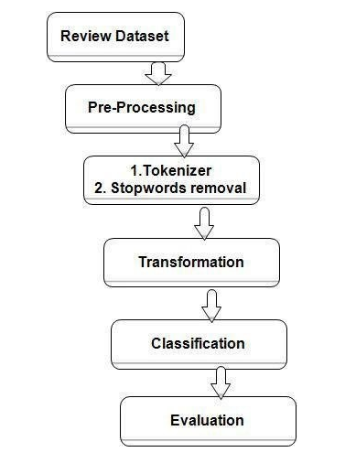

# Fig 1 Overview of steps

# 5. METHODOLOGY

An optimized AI-enabled sentiment analysis on the COVID-19 pandemic methodology involves collecting diverse and representative text data, pre-processing the data, analysing the data using advanced AI techniques, evaluating the approach, addressing ethical concerns, and presenting the results in an easily understandable format. The following methodology will be followed to achieve the objectives defined for proposed research work:

1. Detailed study of the problem statement will be done.

2. Installation and hands-on experience on existing approaches like NumPy, Pandas, NLTK and Matplotlib will be done. Relative pros and cons will be identified.

3. Various parameters will be identified to evaluate the proposed system.

4. comparison of new implemented approaches with existing approaches will be done.

# 6. EXPERIMENTAL SETUP

# The experimental setup for an optimized artificial intelligence (AI) enabled sentiment analysis on the COVID-19 pandemic can be divided into several components, including:

# 1. Data Collection: The first step is to collect relevant text data from various sources, including social media, news articles, and online forums. The data should be diverse and representative of different regions, languages, and demographics.

# 2. Data Pre-processing: Once the data is collected, it needs to be pre-processed to remove noise, such as irrelevant text, punctuation, and stop words. This step also involves text normalization, stemming, and lemmatization to prepare the data for sentiment analysis.

# 3. Feature Extraction: Feature extraction involves selecting relevant features from the pre-processed text data that can be used to train the sentiment analysis model. Common features include word frequency, n-grams, and part-of-speech tags.

# 4. Sentiment Analysis Model Training: The next step is to train a sentiment analysis model using machine learning algorithms, such as support vector machines, random forests, or neural networks. The model should be trained on a labelled dataset with sentiment annotations for each text sample.

# 5. Model Evaluation: Once the sentiment analysis model is trained, it needs to be evaluated on a test dataset to assess its accuracy and performance. Common evaluation metrics include precision, recall, F1-score, and confusion matrix.

# 6. Optimization: The final step is to optimize the sentiment analysis model to improve its accuracy and performance. This can be achieved by fine-tuning the model parameters, using different feature extraction techniques, or combining multiple models in an ensemble.

**Details about Tools:**

Machine Learning is a subset of AI that can automatically learn and improve accordingly from experience without being explicitly programmed. ML-Based algorithms primarily based on characteristic features. A complex and huge amount of data can be developed by using ML-based techniques. These techniques have been widely used for finding the patterns of epidemics and for forecasting purposes. With regards to the covid 19 pandemic, such techniques have been used by several researchers for screening, classification, diagnosis, drug repurposing, and prediction of covid-19.

**Support Vector Machine (SVM):**

Support vector machine (SVM) is a powerful tool used for solving classification and regression problems. It has been in numerous real-world applications, including the health sector, due to its high accuracy and performance. Therefore, recently, SVM has been used for combating the COVID-19 pandemic because of its superior performance.

**Random Forest (RF):**

The random forest algorithm (RF) is a statistical tool and is one of the most promising classifiers used to solve classification and regression problems. Multiple trees are used for the training and prediction of data samples. RF has been widely used in bioinformatics and chemometrics.

#### **Decision Tree (DT):**

The decision tree (DT) algorithm is a mathematical tool used for solving regression and classification problems. Due to its easy usage and robustness, DT has been widely used in several fields. Recently, DT has become well-known in the medical research and health sector. For instance, the model-based decision trees were developed for the severity detection of COVID-19 in children.

#### **Logistic Regression (LR):**

Logistic regression (LR) is a statistical tool and regression analysis that uses a logistic function to model a binary dependent variable and is used when the target variable is categorical. More recently, LR has been used in mitigating the COVID-19 pandemic. The diagnosis of COVID-19 was performed using multivariate logistic regression using a dataset of 620 samples from the laboratory. The distribution of samples for the training set was 431 samples and 189 samples for the testing set. The performance of the proposed model was satisfactory with a positive predictive value of 86.35% and 86.62% for the negative predictive value.

#### **Other Machine Learning methods:**

Besides SVM, RF, DT, and LR, other ML-based approaches such as multilayer perceptron (MLP), xgboost, k-means, gaussian process regression (GPR), and neural networks have also been used in the screening, detection, prediction, and forecasting of COVID-19.

**NUMPY:**

NumPy is the fundamental package for scientific computing in Python. It is a Python library that provides a multidimensional array object, various derived objects (such as masked arrays and matrices), and an assortment of routines for fast operations on arrays, including mathematical, logical, shape manipulation, sorting, selecting, I/O, discrete Fourier transforms, basic linear algebra, basic statistical operations, random simulation and much more.

**PANDAS:**

Pandas is a Python library used for working with data sets. It has functions for analyzing, cleaning, exploring, and manipulating data. Pandas allows us to analyze big data and make conclusions based on statistical theories. Pandas can clean messy data sets, and make them readable and relevant. Relevant data is very important in data science.

**MATPLOTLIB:**

Matplotlib is a python library used to create 2D graphs and plots by using python scripts. It has a module named pyplot which makes things easy for plotting by providing feature to control line styles, font properties, formatting axes etc. It supports a very wide variety of graphs and plots namely - histogram, bar charts, power spectra, error charts etc. It is used along with NumPy to provide an environment that is an effective open-source alternative for MatLab. It can also be used with graphics toolkits like PyQt and wxPython.

**NLTK:**

NLTK is a leading platform for building Python programs to work with human language data. It provides easy-to-use interfaces to over 50 corpora and lexical resources such as WordNet, along with a suite of text processing libraries for classification, tokenization, stemming, tagging, parsing, and semantic reasoning, wrappers for industrial-strength NLP libraries, and an active discussion forum.

**CODE:**

**1.Importing Libraries.**

import pandas as pd

import numpy as np

from numpy import percentile

import matplotlib.pyplot as plt

import seaborn as sns

import matplotlib

import re # for regular expressions

import pandas as pd

pd.set_option("display.max_colwidth", 200)

import string

import nltk # for text manipulation

from nltk.stem.porter import *

from sklearn.feature_extraction.text import TfidfVectorizer, CountVectorizer

from tqdm import tqdm

from gensim.models.doc2vec import LabeledSentence

import gensim

from sklearn.linear_model import LogisticRegression

from scipy import stats

from sklearn import metrics

from sklearn.metrics import mean_squared_error,mean_absolute_error, make_scorer,classification_report,confusion_matrix,accuracy_score,roc_auc_score,roc_curve

from sklearn.model_selection import train_test_split,cross_val_score,KFold

from sklearn.model_selection import train_test_split

from sklearn.metrics import f1_score

from sklearn.naive_bayes import BernoulliNB

from sklearn import svm

from sklearn.ensemble import RandomForestClassifier

from xgboost import XGBClassifier

import xgboost as xgb

import warnings

warnings.filterwarnings("ignore")

%matplotlib inline

df = pd.read_csv("Copy of Coronavirus Tweets.csv")

# ****2. Reviewing Our Dataset****

df.head()

df.info()

df.shape

df.columns

df.TweetAt.value_counts()

df.TweetAt.value_counts()

df['Location'].value_counts()

df['Sentiment'].value_counts()

# Going deeper into tweet and sentiment.

df[df['Sentiment']=='Extremely Negative']

df[df['Sentiment']=='Extremely Negative'].loc[20,'OriginalTweet']

df[df['Sentiment']=='Extremely Negative'].loc[20,'OriginalTweet']

df[df['Sentiment']=='Negative']

df[df['Sentiment']=='Negative'].loc[41149,'OriginalTweet']

df[df['Sentiment']=='Neutral']

df[df['Sentiment']=='Neutral'].loc[17,'OriginalTweet']

df[df['Sentiment']=='Neutral'].loc[16,'OriginalTweet']

df[df['Sentiment']=='Positive']

df[df['Sentiment']=='Positive'].loc[1,'OriginalTweet']

df[df['Sentiment']=='Positive'].loc[6,'OriginalTweet']

df[df['Sentiment']=='Extremely Positive']

df[df['Sentiment']=='Extremely Positive'].loc[11,'OriginalTweet']

df[df['Sentiment']=='Extremely Positive'].loc[22,'OriginalTweet']

pd.isnull(df["Sentiment"])

# Looking For Null Values

missing_values = pd.DataFrame()

missing_values['column'] = df.columns

missing_values['percent'] = [round(100* df[col].isnull().sum() / len(df), 2) for col in df.columns]

missing_values = missing_values.sort_values('percent')

missing_values = missing_values[missing_values['percent']>0]

plt.figure(figsize=(15, 5))

sns.set(style='whitegrid', color_codes=True)

splot=sns.barplot(x='column', y='percent', data=missing_values)

for p in splot.patches:

splot.annotate(format(p.get_height(), '.2f'), (p.get_x() + p.get_width() / 2., p.get_height()), ha = 'center',

va = 'center', xytext = (0, 9), textcoords = 'offset points')

plt.xlabel("Column_Name", size=14, weight="bold")

plt.ylabel("Percentage", size=14, weight="bold")

plt.title("Percentage of missing values in column",fontweight="bold",size=17)

plt.show()

# Heat Map for missing values

plt.figure(figsize=(17, 5))

sns.heatmap(df.isnull(), cbar=True, yticklabels=False)

plt.xlabel("Column_Name", size=14, weight="bold")

plt.title("Places of missing values in column",fontweight="bold",size=17)

plt.show()

# Unique Values In Each Feature Coulmn

unique_df = pd.DataFrame()

unique_df['Features'] = df.columns

unique=[]

for i in df.columns:

unique.append(df[i].nunique())

unique_df['Uniques'] = unique

f, ax = plt.subplots(1,1, figsize=(15,7))

splot = sns.barplot(x=unique_df['Features'], y=unique_df['Uniques'], alpha=0.8)

for p in splot.patches:

splot.annotate(format(p.get_height(), '.0f'), (p.get_x() + p.get_width() / 2., p.get_height()), ha = 'center',

va = 'center', xytext = (0, 9), textcoords = 'offset points')

plt.title('Bar plot for number of unique values in each column',weight='bold', size=15)

plt.ylabel('#Unique values', size=12, weight='bold')

plt.xlabel('Features', size=12, weight='bold')

plt.xticks(rotation=90)

plt.show()

# Plot Of Top 15 Locations Of Tweet.

loc_analysis = pd.DataFrame(df['Location'].value_counts().sort_values(ascending=False))

loc_analysis = loc_analysis.rename(columns={'Location':'count'})

import plotly.graph_objects as go

data = {

"values": loc_analysis['count'][:15],

"labels": loc_analysis.index[:15],

"domain": {"column": 0},

"name": "Location Name",

"hoverinfo":"label+percent+name",

"hole": .4,

"type": "pie"

}

layout = go.Layout(title="<b>Ratio on Location</b>", legend=dict(x=0.1, y=1.1, orientation="h"))

data = [data]

fig = go.Figure(data = data, layout = layout)

fig.update_layout(title_x=0.5)

fig.show()

sns.catplot("TweetAt", data=df, kind="count", height=8)

# Top 10 locations of tweet

Top_Location_Of_tweet= df['Location'].value_counts().head(10)

sns.set(rc={'figure.figsize':(12,8)})

sns.set_style('white')

# Top_Location_Of_tweet.head(10)

Top_Location_Of_tweet_df=pd.DataFrame(Top_Location_Of_tweet)

Top_Location_Of_tweet_df.reset_index(inplace=True)

Top_Location_Of_tweet_df.rename(columns={'index':'Location', 'Location':'Location_Count'}, inplace=True)

Top_Location_Of_tweet_df

viz_1=sns.barplot(x="Location",y="Location_Count", data=Top_Location_Of_tweet_df,

palette='Blues_d')

viz_1.set_title('Locations with most of the tweets')

viz_1.set_ylabel('Count of listings')

viz_1.set_xlabel('Location Names')

viz_1.set_xticklabels(viz_1.get_xticklabels(), rotation=45)

# Sentiments Countplot

sns.set(font_scale=1.1)

sns.catplot("Sentiment", data=df, kind="count", height=8)

df.TweetAt.value_counts()

# Data Preprocessing

1. **Removing @user**

# write function for removing @user

def remove_pattern(input_txt, pattern):

r = re.findall(pattern, input_txt)

for i in r:

input_txt = re.sub(i,'',input_txt)

return input_txt

df['Tweet'] = np.vectorize(remove_pattern)(df['OriginalTweet'], '@[\w]*')

df.head(2)

**REMOVED HTTP AND URLS FROM TWEET**

**import re**

**df['Tweet'] = df['Tweet'].apply(lambda x: re.split('https:\/\/.*', str(x))[0])**

**df.head(3)**

1. **Removing Punctuations, Numbers, and Special Characters**

**df['Tweet'] = df['Tweet'].str.replace('[^a-zA-Z#]+',' ')**

**df.head(5)**

1. **Removing Short Words**

**df['Tweet'] = df['Tweet'].apply(lambda x: ' '.join([w for w in x.split() if len(w) > 2]))**

**df.head(2)**

1. **Tokenization**

**tokenized_tweet = df['Tweet'].apply(lambda x: x.split())**

**df.head(2)**

1. **Stemming**

**from nltk.stem.porter import \***

**stemmer = PorterStemmer()**

**# apply stemmer for tokenized_tweet**

**tokenized_tweet = tokenized_tweet.apply(lambda x: [stemmer.stem(i) for i in x])**

# ****Story Generation and Visualization from Tweets****

1. **Understanding the common words used in the tweets: WordCloud**

all_words = ' '.join([text for text in df['Tweet']])

from wordcloud import WordCloud

wordcloud = WordCloud(width=800, height=500, random_state=21, max_font_size=110).generate(all_words)

plt.figure(figsize=(10, 7))

plt.imshow(wordcloud, interpolation="bilinear")

plt.axis('off')

plt.show()

# create text from just normal tweets

normal_words = ' '.join([text for text in df['Tweet'][df['Sentiment'] == 'Extremely Positive']])

wordcloud = WordCloud(width=800, height=500, random_state=21, max_font_size=110).generate(normal_words)

plt.figure(figsize=(10, 7))

plt.imshow(wordcloud, interpolation="bilinear")

plt.axis('off')

plt.show()

# create text from just normal tweets

normal_words = ' '.join([text for text in df['Tweet'][df['Sentiment'] == 'Positive']])

wordcloud = WordCloud(width=800, height=500, random_state=21, max_font_size=110).generate(normal_words)

plt.figure(figsize=(10, 7))

plt.imshow(wordcloud, interpolation="bilinear")

plt.axis('off')

plt.show()

# create text from just normal tweets

normal_words = ' '.join([text for text in df['Tweet'][df['Sentiment'] == 'Extremely Negative']])

wordcloud = WordCloud(width=800, height=500, random_state=21, max_font_size=110).generate(normal_words)

plt.figure(figsize=(10, 7))

plt.imshow(wordcloud, interpolation="bilinear")

plt.axis('off')

plt.show()

# create text from just normal tweets

normal_words = ' '.join([text for text in df['Tweet'][df['Sentiment'] == 'Negative']])

​

wordcloud = WordCloud(width=800, height=500, random_state=21, max_font_size=110).generate(normal_words)

plt.figure(figsize=(10, 7))

plt.imshow(wordcloud, interpolation="bilinear")

plt.axis('off')

plt.show()

# create text from just normal tweets

normal_words = ' '.join([text for text in df['Tweet'][df['Sentiment'] == 'Neutral']])

wordcloud = WordCloud(width=800, height=500, random_state=21, max_font_size=110).generate(normal_words)

plt.figure(figsize=(10, 7))

plt.imshow(wordcloud, interpolation="bilinear")

plt.axis('off')

plt.show()

**D) Understanding the impact of Hashtags on tweets sentiment**

# function to collect hashtags

def hashtag_extract(x):

hashtags = []

for i in x:

ht = re.findall(r'#(\w+)', i)

hashtags.append(ht)

return hashtags

# extracting hashtags from non racist/sexist tweets

HT_Extremely_Positive = hashtag_extract(df['OriginalTweet'][df['Sentiment'] == 'Extremely Positive'])

HT_Positive = hashtag_extract(df['OriginalTweet'][df['Sentiment'] == 'Positive'])

HT_Neutral = hashtag_extract(df['OriginalTweet'][df['Sentiment'] == 'Neutral'])

HT_Negative = hashtag_extract(df['OriginalTweet'][df['Sentiment'] == 'Negative'])

HT_Extremely_Negative = hashtag_extract(df['OriginalTweet'][df['Sentiment'] == 'Extremely Negative'])

# unnesting list

HT_Extremely_Positive = sum(HT_Extremely_Positive, [])

HT_Positive = sum(HT_Positive, [])

HT_Neutral = sum(HT_Neutral, [])

HT_Negative = sum(HT_Negative,[])

HT_Extremely_Negative = sum(HT_Extremely_Negative,[])

print(HT_Extremely_Positive)

print(HT_Positive)

print(HT_Neutral)

print(HT_Negative)

print(HT_Extremely_Negative)

# making frequency distribution top 10 Extremely Positive hashtags

a = nltk.FreqDist(HT_Extremely_Positive)

d = pd.DataFrame({'Hashtag': list(a.keys()),

'Count' : list(a.values())})

d = d.nlargest(columns = 'Count', n = 10)

plt.figure(figsize = (16,5))

ax = sns.barplot(data =d, x = 'Hashtag', y = 'Count')

plt.show()

# making frequency distribution top 10 Positive hashtags

a = nltk.FreqDist(HT_Positive)

d = pd.DataFrame({'Hashtag': list(a.keys()),

'Count' : list(a.values())})

d = d.nlargest(columns = 'Count', n = 10)

plt.figure(figsize = (16,5))

ax = sns.barplot(data =d, x = 'Hashtag', y = 'Count')

plt.show()

# making frequency distribution top 10 Positive hashtags

a = nltk.FreqDist(HT_Neutral)

d = pd.DataFrame({'Hashtag': list(a.keys()),

'Count' : list(a.values())})

d = d.nlargest(columns = 'Count', n = 10)

plt.figure(figsize = (16,5))

ax = sns.barplot(data =d, x = 'Hashtag', y = 'Count')

plt.show()

# making frequency distribution top 10 Positive hashtags

a = nltk.FreqDist(HT_Negative)

d = pd.DataFrame({'Hashtag': list(a.keys()),

'Count' : list(a.values())})

d = d.nlargest(columns = 'Count', n = 10)

plt.figure(figsize = (16,5))

ax = sns.barplot(data =d, x = 'Hashtag', y = 'Count')

plt.show()

# making frequency distribution top 10 Extremely Negative hashtags

a = nltk.FreqDist(HT_Extremely_Negative)

d = pd.DataFrame({'Hashtag': list(a.keys()),

'Count' : list(a.values())})

d = d.nlargest(columns = 'Count', n = 10)

plt.figure(figsize = (16,5))

ax = sns.barplot(data =d, x = 'Hashtag', y = 'Count')

plt.show()

**#4. Extracting Features from Cleaned Tweet**

new_df = df[['Tweet','Sentiment']]

new_df.head()

df['Sentiment'].value_counts()

**Removing Stopwords**

nltk.download('stopwords')

from nltk.corpus import stopwords

stop = stopwords.words('english')

new_df['Tweet'].apply(lambda x: [item for item in x if item not in stop])

new_df.head(6)

new_df.shape

new_df.isnull().sum()

new_df.head(7)

**Spitting Our Dataset into Training And Testing Dataset ( For Multiclass Classification)**

from sklearn.model_selection import train_test_split

train,valid = train_test_split(new_df,test_size = 0.2,random_state=0,stratify = new_df.Sentiment.values) #stratification means that the train_test_split method returns training and test subsets that have the same proportions of class labels as the input dataset.

print("train shape : ", train.shape)

print("valid shape : ", valid.shape)

**Use Of Counter Vectorizer For Multi Class Classification**

from sklearn.feature_extraction.text import CountVectorizer

from nltk.corpus import stopwords

stop = list(stopwords.words('english'))

vectorizer = CountVectorizer(decode_error = 'replace',stop_words = stop)

X_train = vectorizer.fit_transform(train.Tweet.values)

X_valid = vectorizer.transform(valid.Tweet.values)

y_train = train.Sentiment.values

y_valid = valid.Sentiment.values

print("X_train.shape : ", X_train.shape)

print("X_train.shape : ", X_valid.shape)

print("y_train.shape : ", y_train.shape)

print("y_valid.shape : ", y_valid.shape)

**Naive Bayes Classifier for MULTICLASS Classification**

from sklearn.naive_bayes import MultinomialNB

naiveByes_clf = MultinomialNB()

naiveByes_clf.fit(X_train,y_train)

NB_prediction = naiveByes_clf.predict(X_valid)

NB_accuracy = accuracy_score(y_valid,NB_prediction)

print("training accuracy Score : ",naiveByes_clf.score(X_train,y_train))

print("Validation accuracy Score : ",NB_accuracy )

print(classification_report(NB_prediction,y_valid))

**Stochastic Gradient Descent-SGD Classifier( MULTICLASS CLASSIFICATION)**

from sklearn.linear_model import SGDClassifier

sgd_clf = SGDClassifier(loss = 'hinge', penalty = 'l2', random_state=0)

sgd_clf.fit(X_train,y_train)

sgd_prediction = sgd_clf.predict(X_valid)

sgd_accuracy = accuracy_score(y_valid,sgd_prediction)

print("Training accuracy Score : ",sgd_clf.score(X_train,y_train))

print("Validation accuracy Score : ",sgd_accuracy )

print(classification_report(sgd_prediction,y_valid))

**RANDOM FOREST CLASSIFIER (For Multiclass Classification)**

from sklearn.ensemble import RandomForestClassifier

rf_clf = RandomForestClassifier()

rf_clf.fit(X_train,y_train)

rf_prediction = rf_clf.predict(X_valid)

rf_accuracy = accuracy_score(y_valid,rf_prediction)

print("Training accuracy Score : ",rf_clf.score(X_train,y_train))

print("Validation accuracy Score : ",rf_accuracy )

print(classification_report(rf_prediction,y_valid))

**Extreme Gradient Boosting ( For Multiclass Classification)**

#takes huge amount of time to execute

import xgboost as xgb

xgboost_clf = xgb.XGBClassifier()

xgboost_clf.fit(X_train, y_train)

xgb_prediction = xgboost_clf.predict(X_valid)

xgb_accuracy = accuracy_score(y_valid,xgb_prediction)

print("Training accuracy Score : ",xgboost_clf.score(X_train,y_train))

print("Validation accuracy Score : ",xgb_accuracy )

print(classification_report(xgb_prediction,y_valid))

**Support vector machine( For Multiclass Classification)**

from sklearn.svm import SVC

svc = SVC()

svc.fit(X_train, y_train)

svc_prediction = svc.predict(X_valid)

svc_accuracy = accuracy_score(y_valid,svc_prediction)

print("Training accuracy Score : ",svc.score(X_train,y_train))

print("Validation accuracy Score : ",svc_accuracy )

print(classification_report(svc_prediction,y_valid))

**Logistic Regression(For Multiclass Classification)**

from sklearn.linear_model import LogisticRegression

logreg = LogisticRegression()

logreg.fit(X_train, y_train)

logreg_prediction = logreg.predict(X_valid)

logreg_accuracy = accuracy_score(y_valid,logreg_prediction)

print("Training accuracy Score : ",logreg.score(X_train,y_train))

print("Validation accuracy Score : ",logreg_accuracy )

print(classification_report(logreg_prediction,y_valid))

**All the multiclass models test accuracy in descending order**

models = pd.DataFrame({

'Model': ['Support Vector Machines', 'Logistic Regression',

'Random Forest', 'Naive Bayes',

'Stochastic Gradient Decent', 'XGBoost',],

'Test accuracy': [svc_accuracy, logreg_accuracy,

rf_accuracy, NB_accuracy,

sgd_accuracy, xgb_accuracy,catboost_accuracy]})

models.sort_values(by='Test accuracy', ascending=False)

**RESULTS:**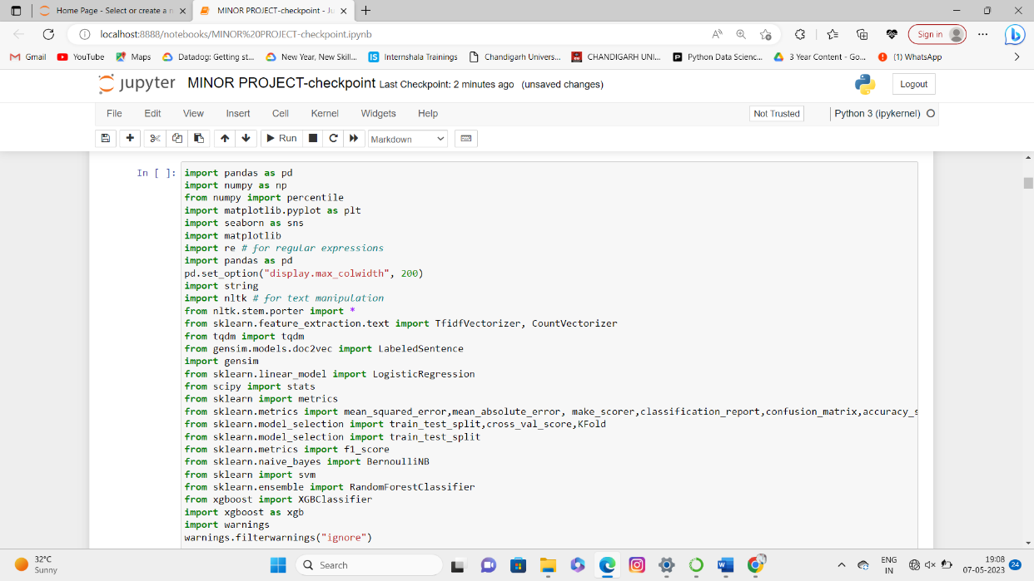

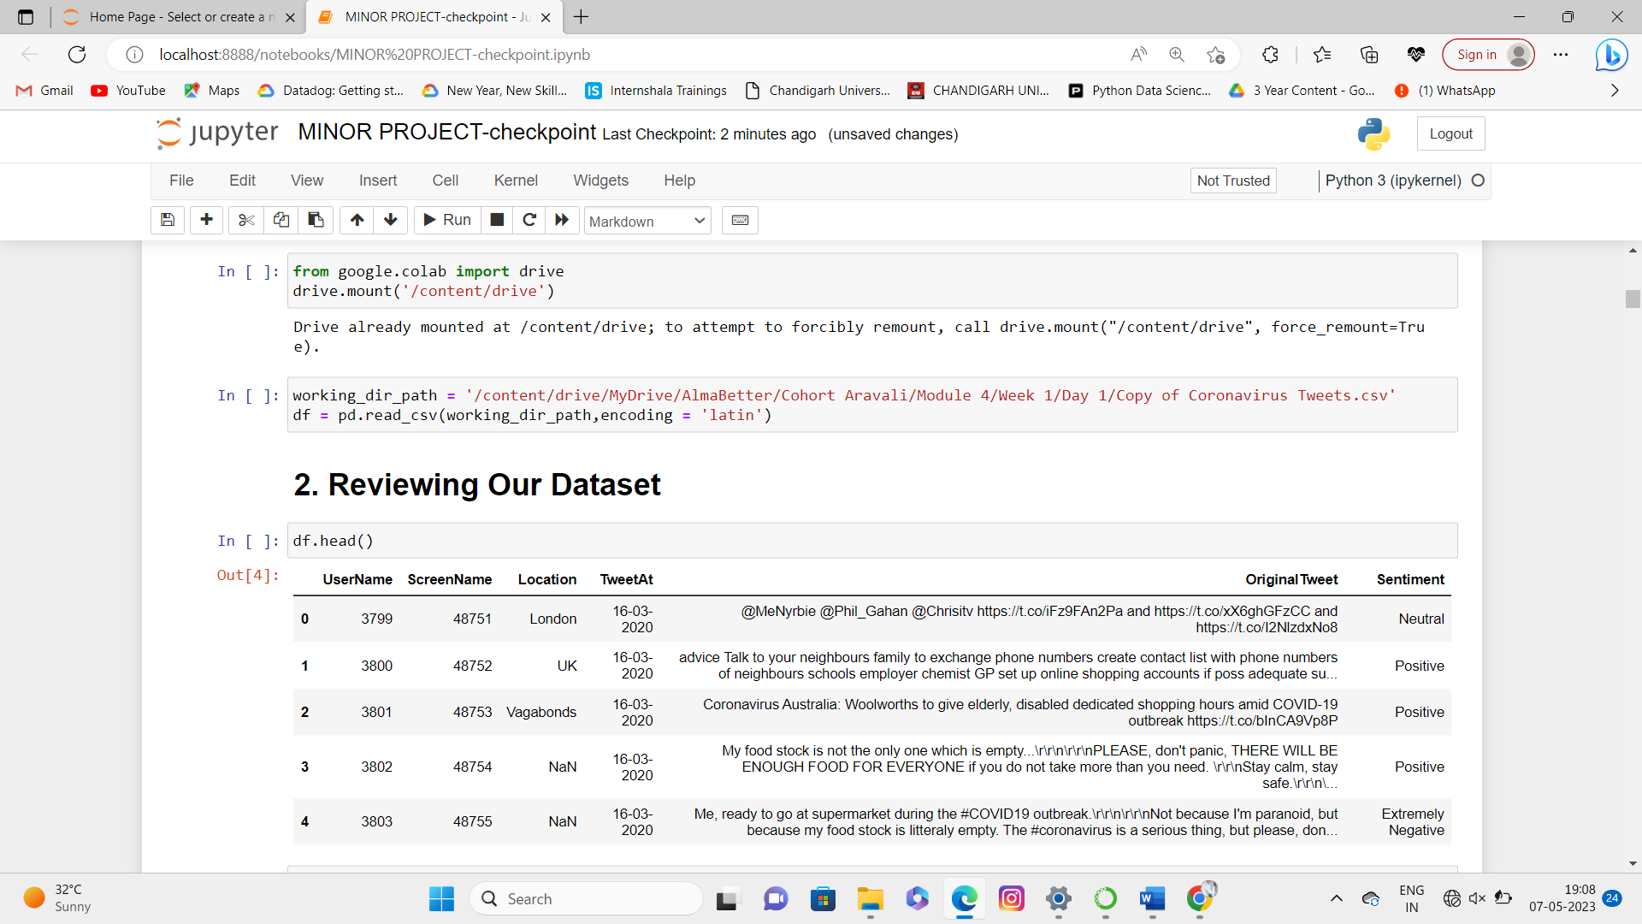

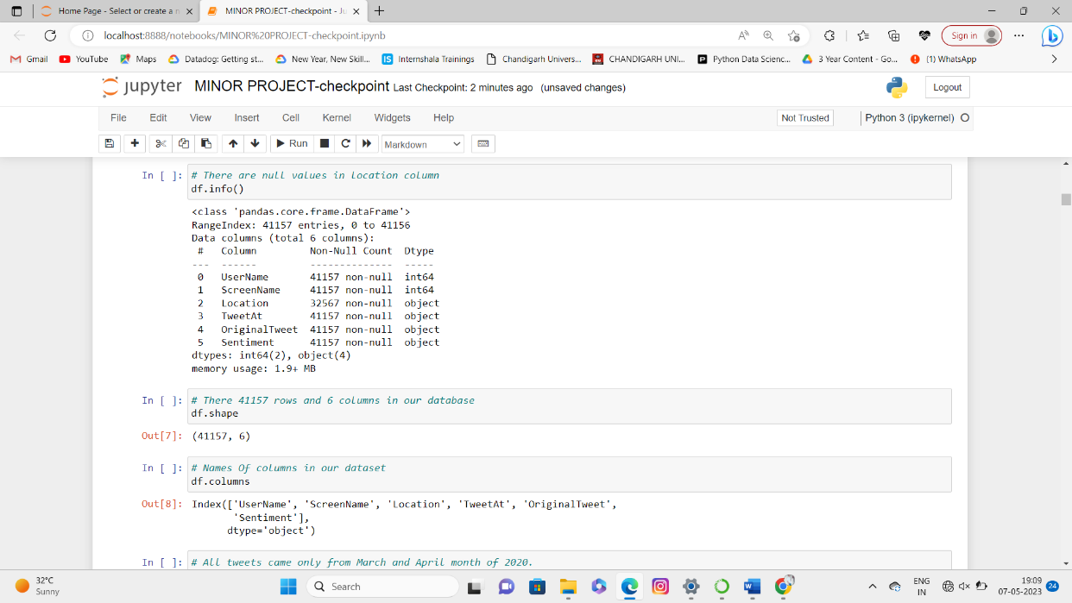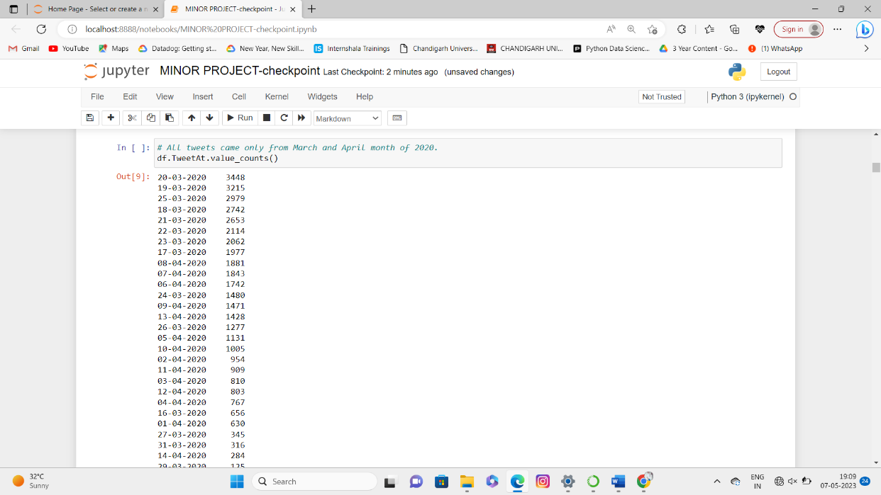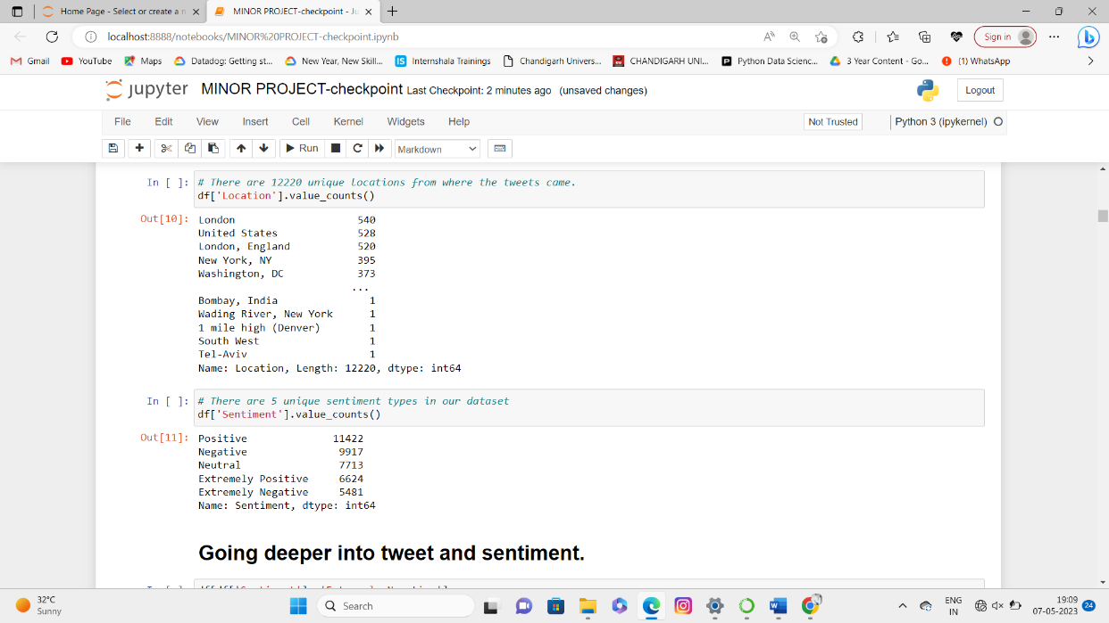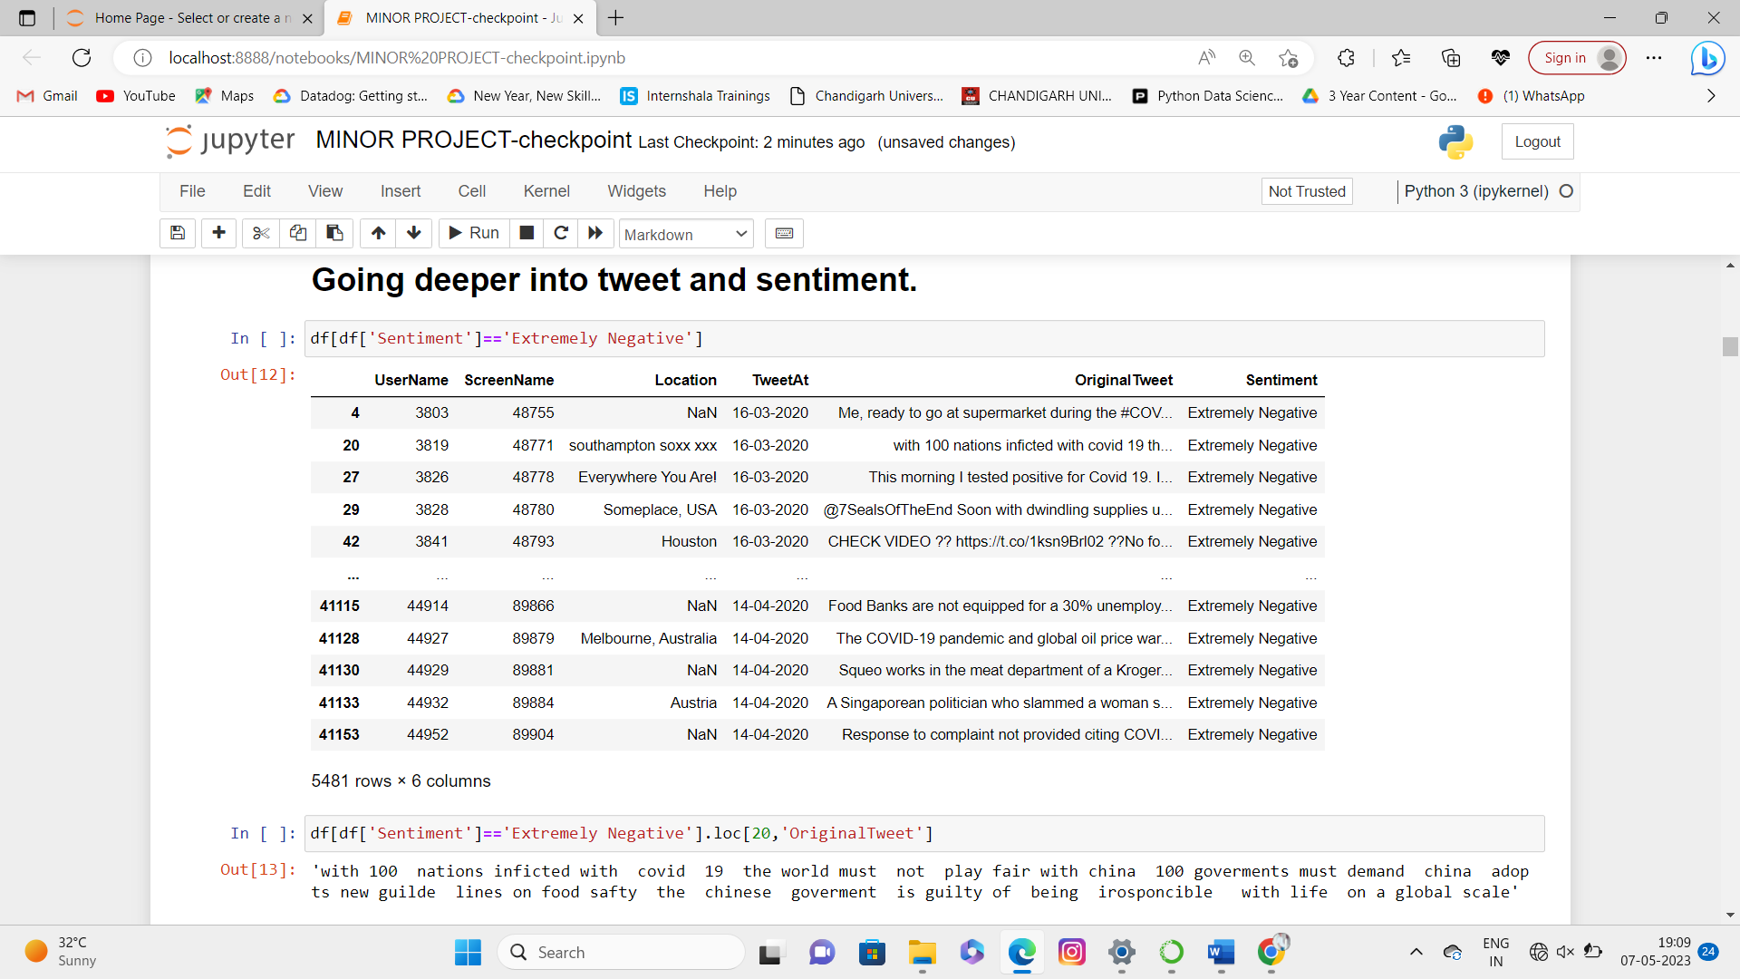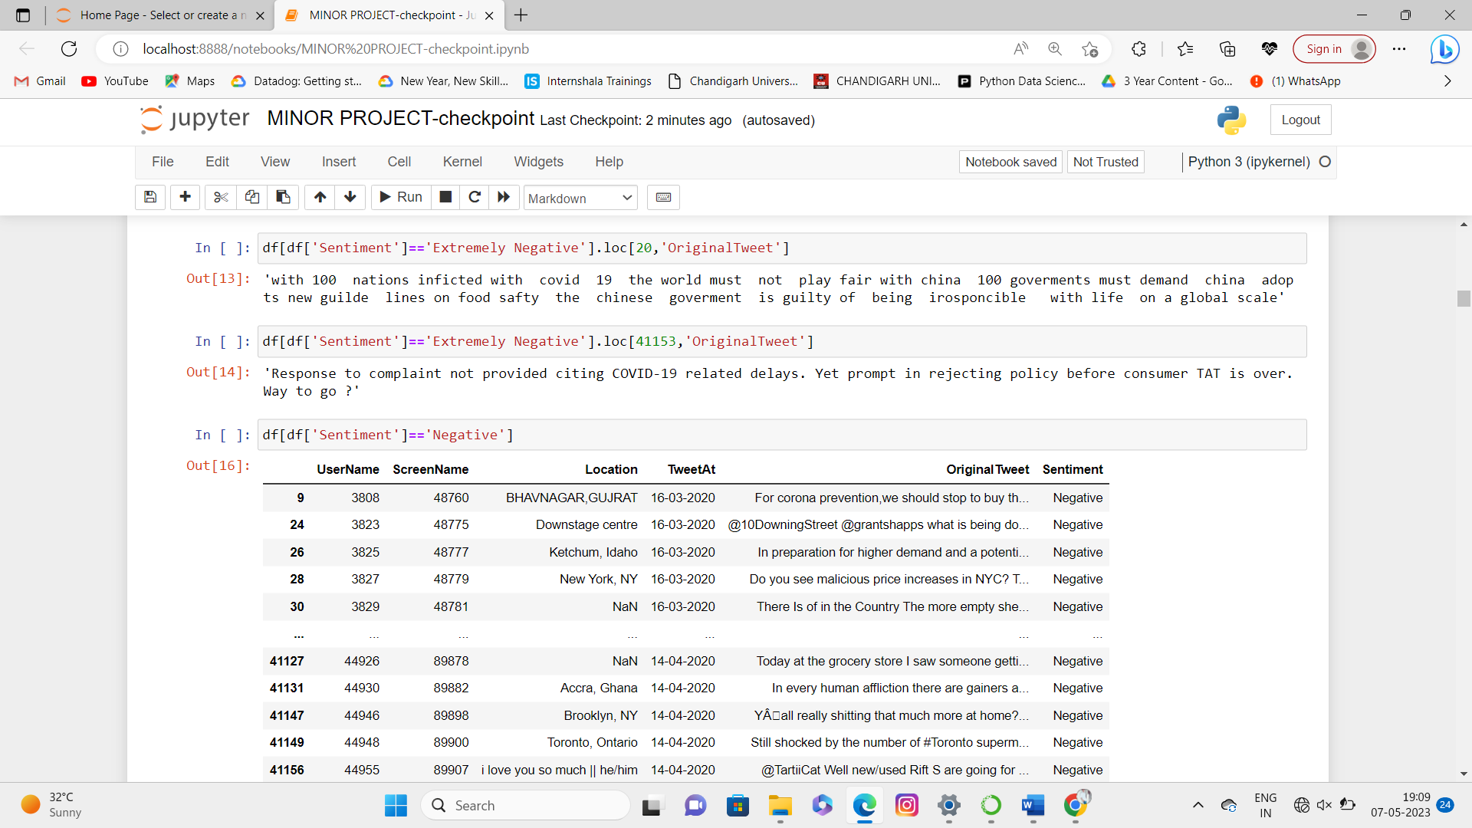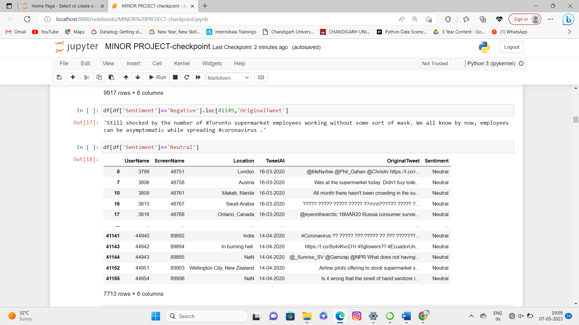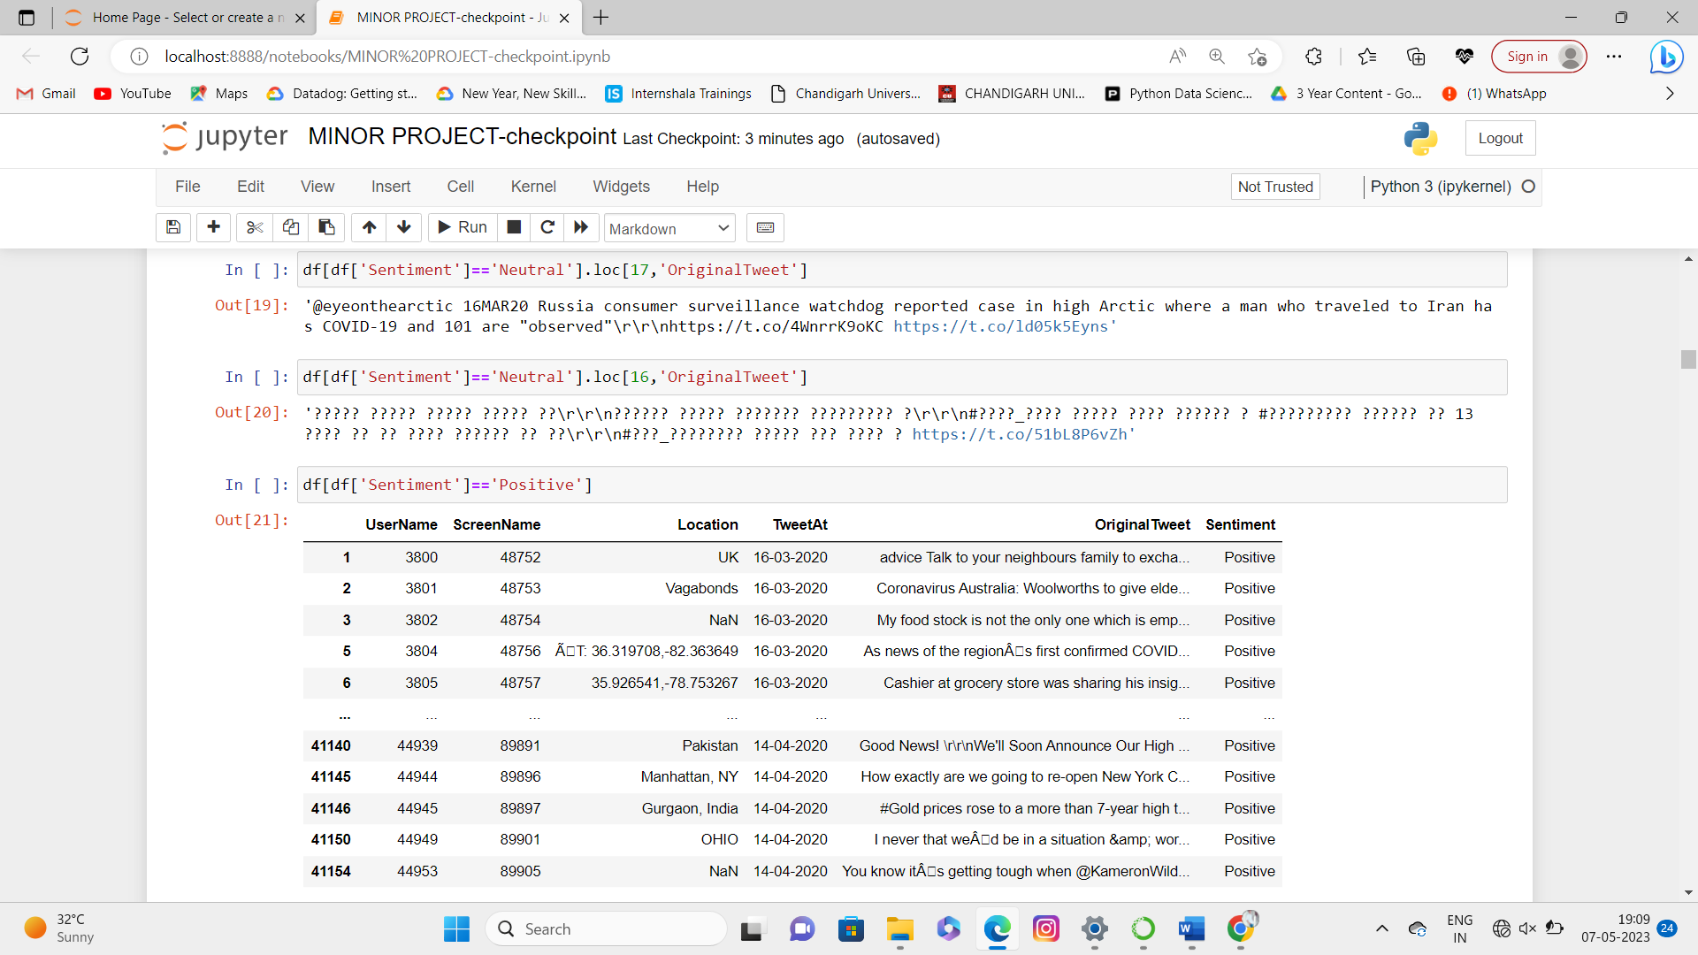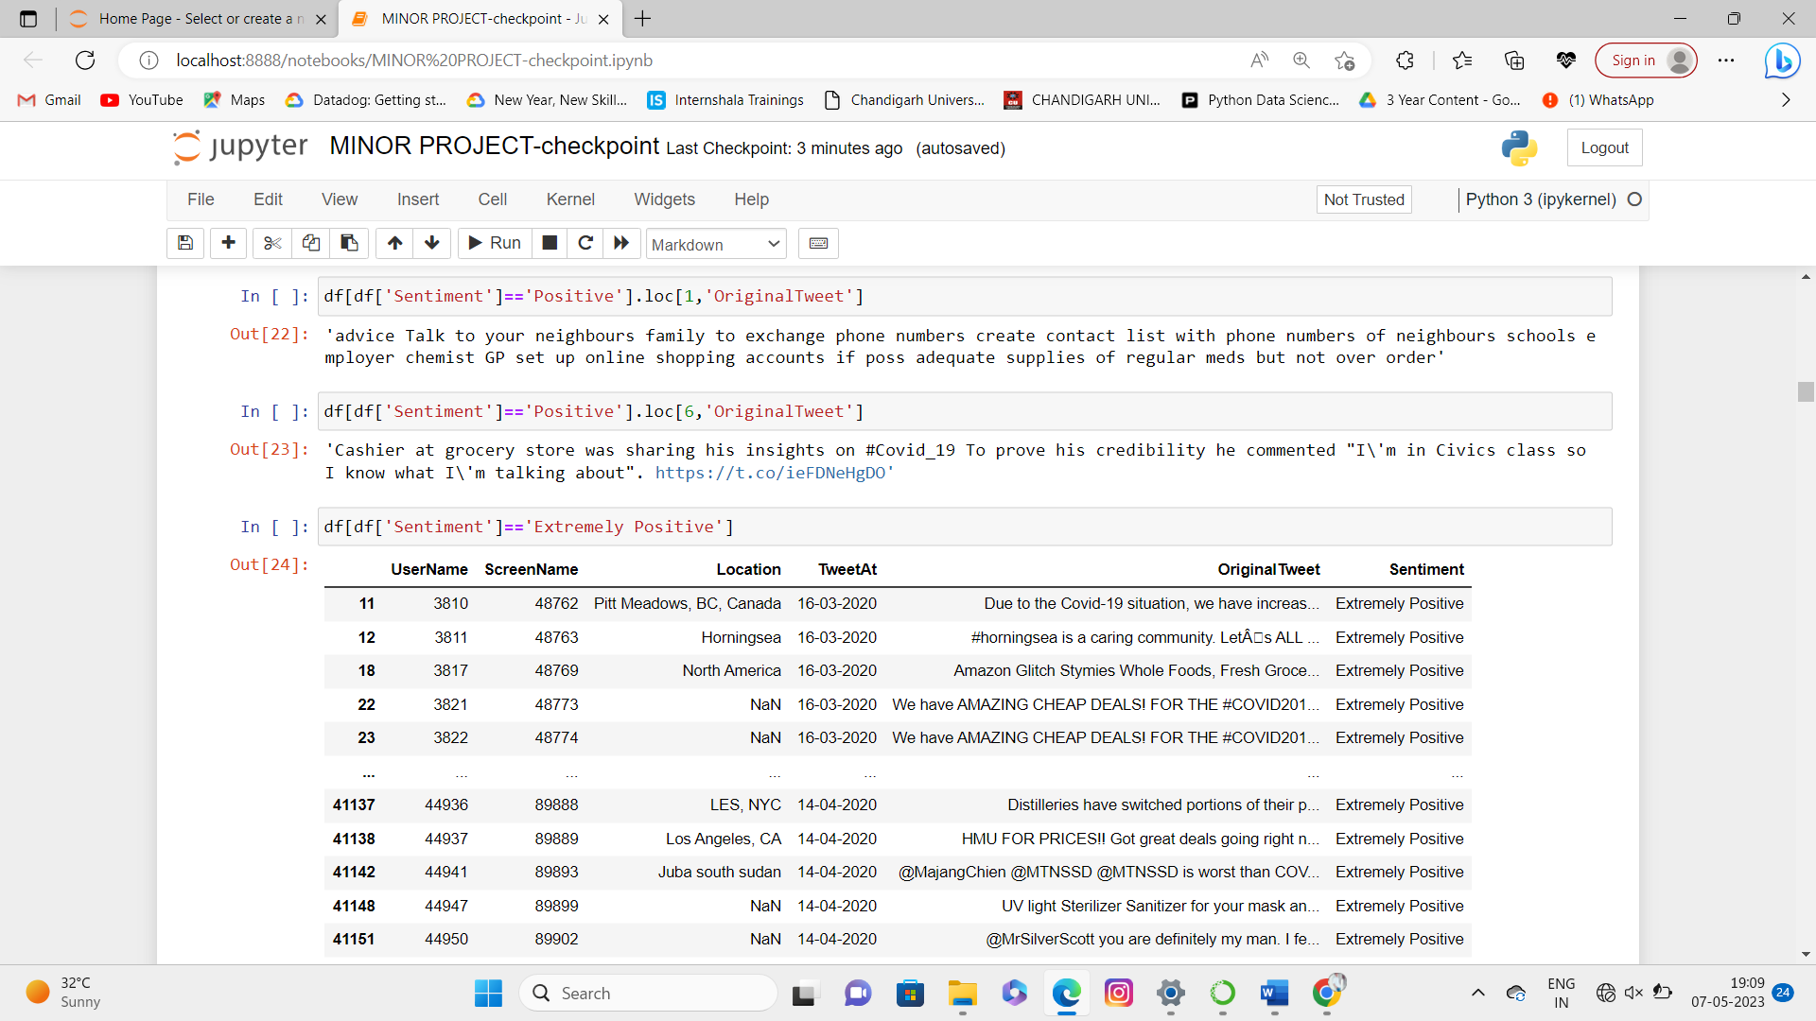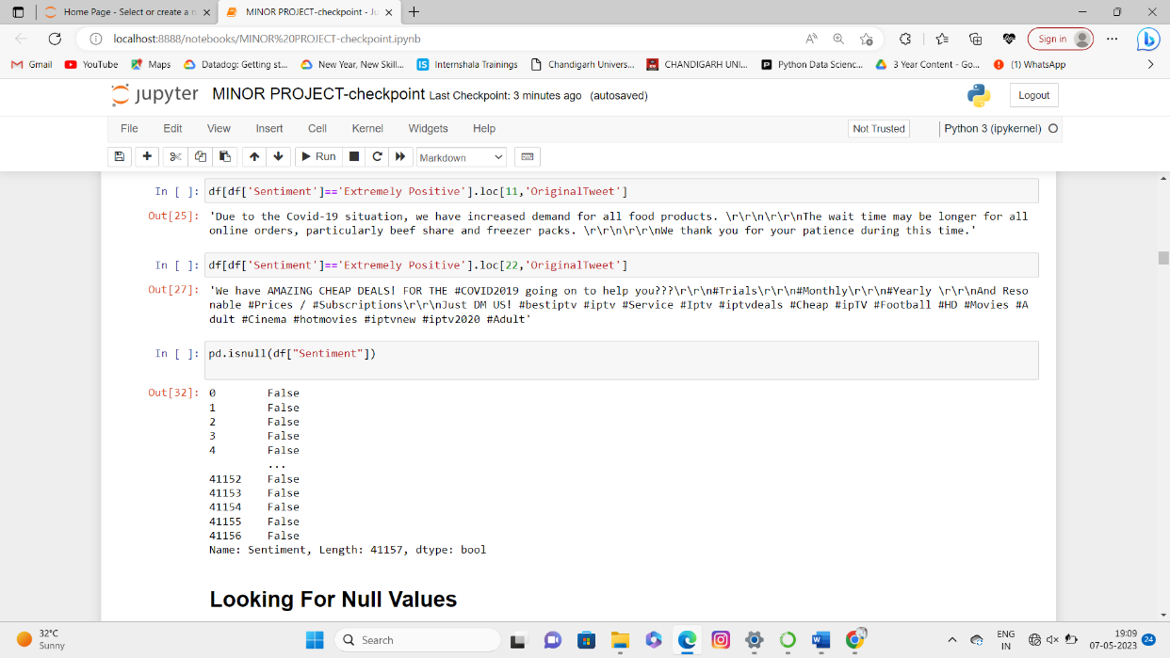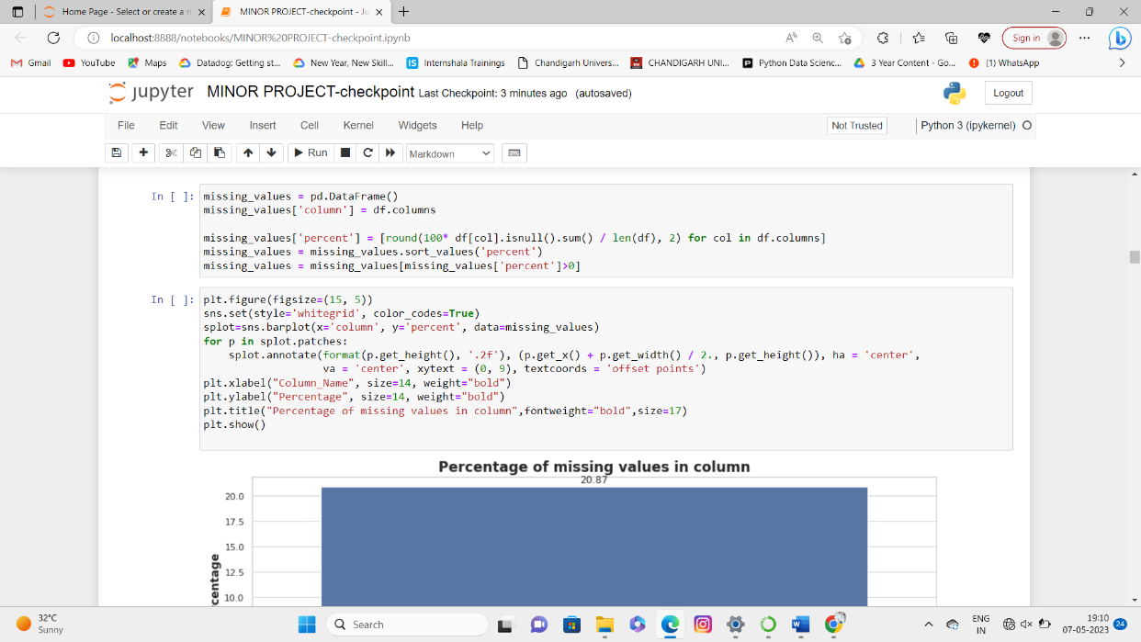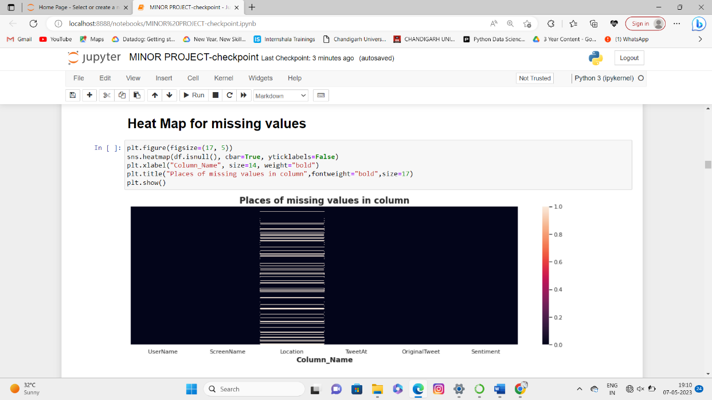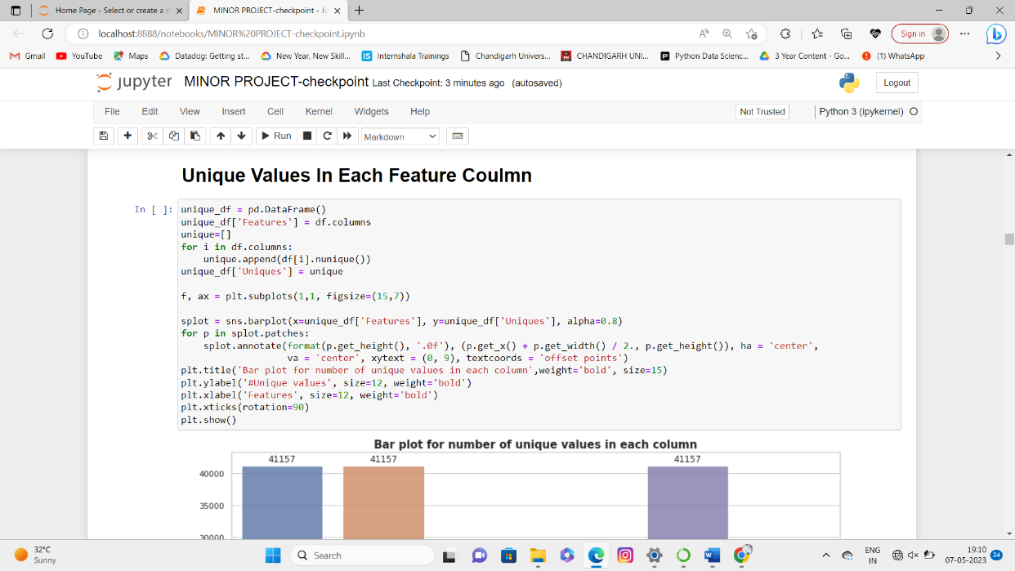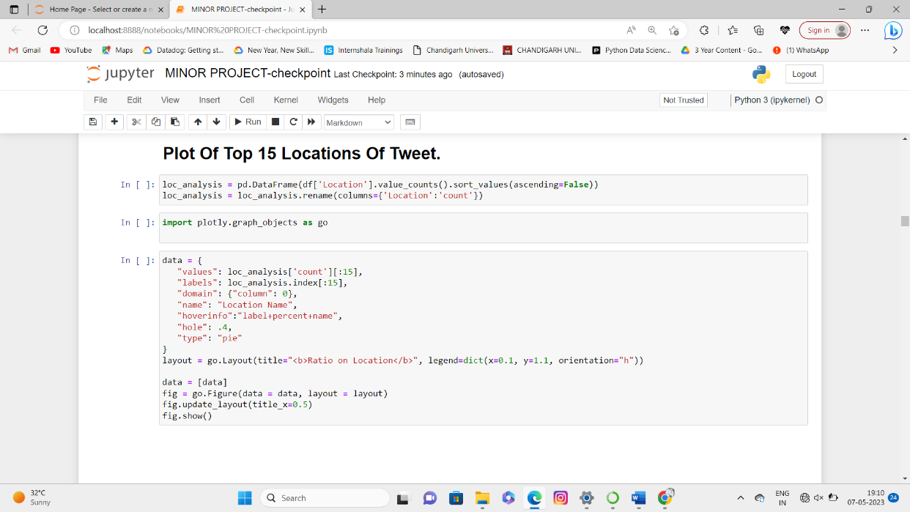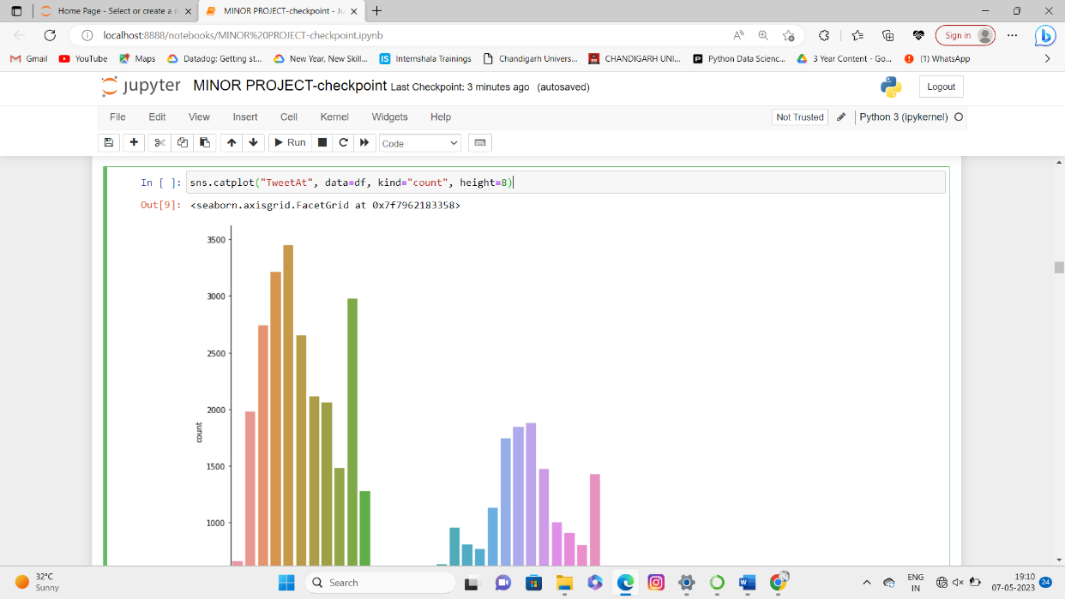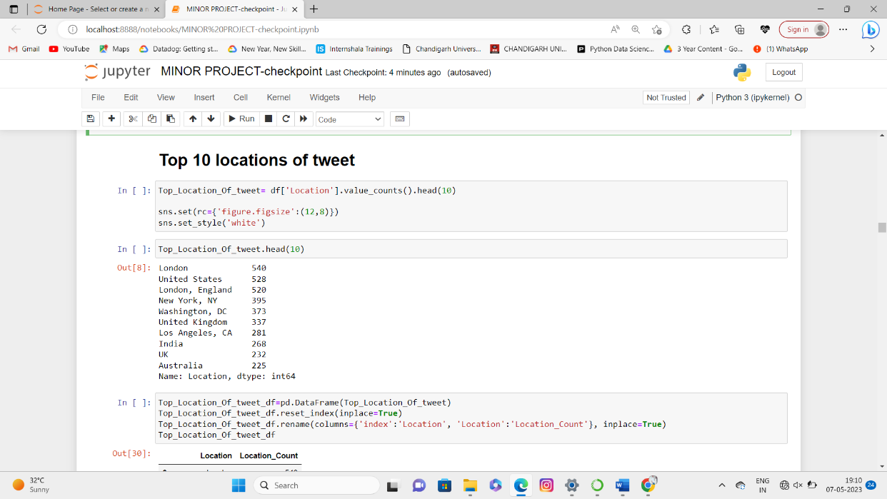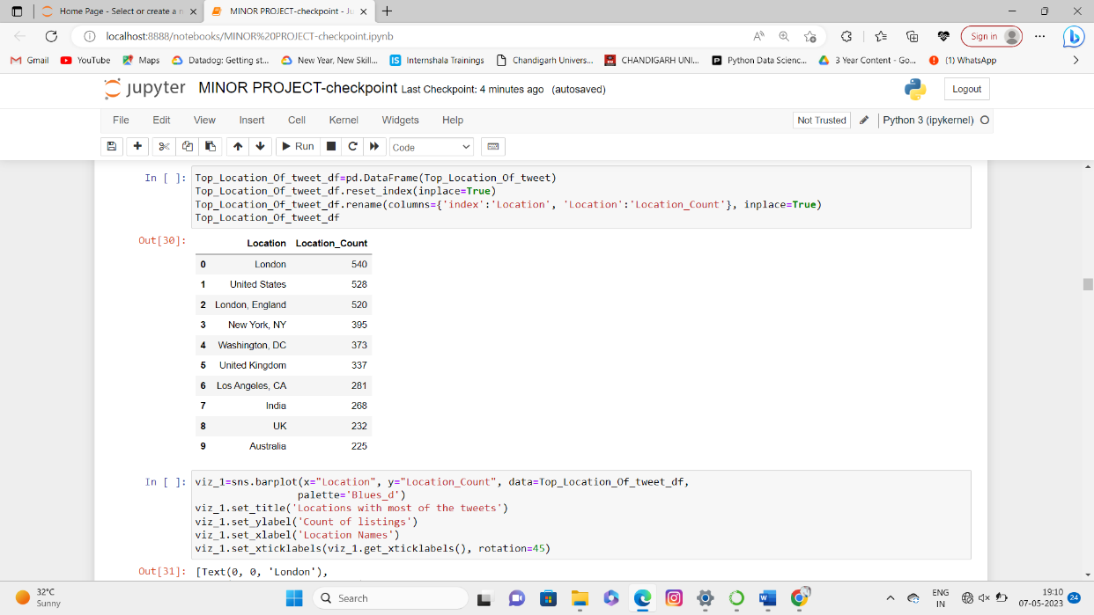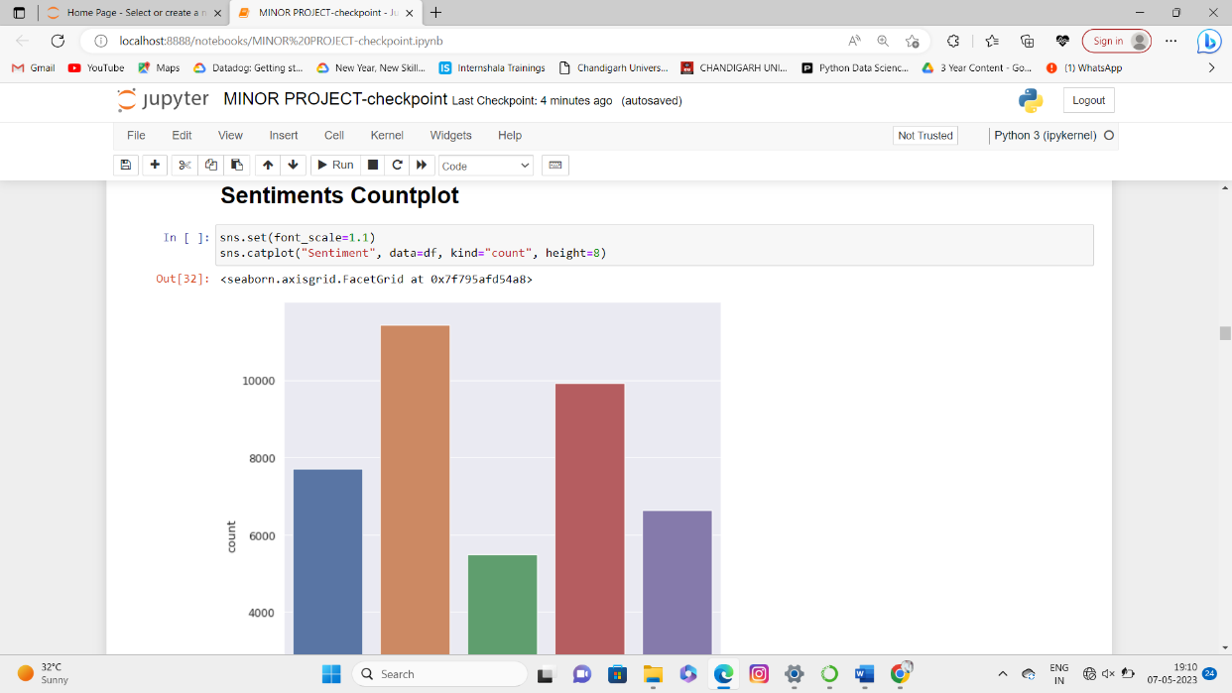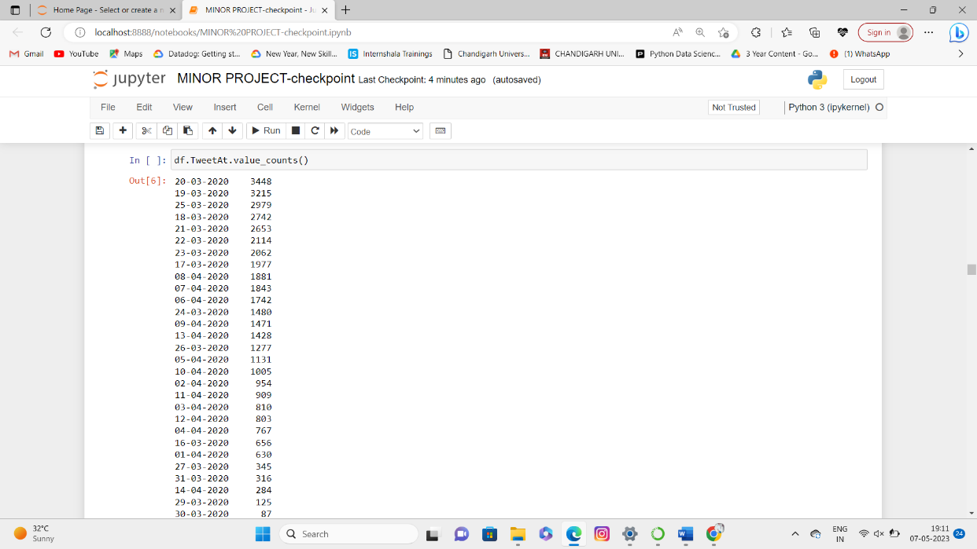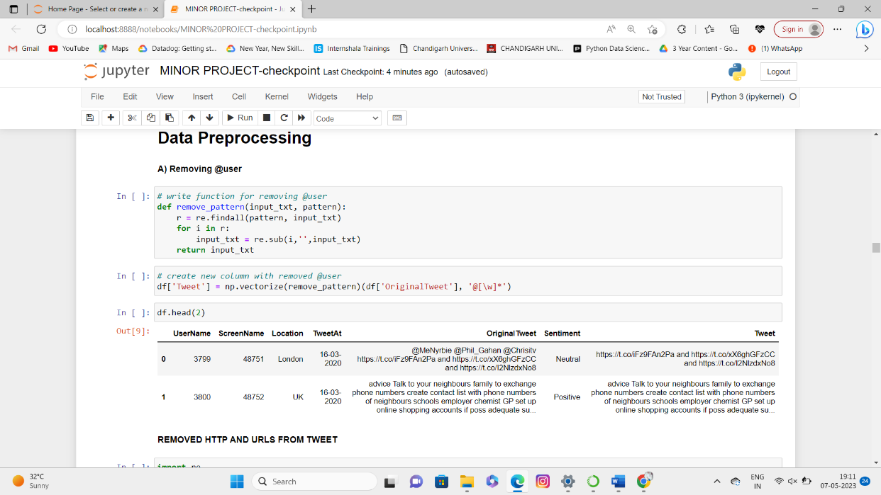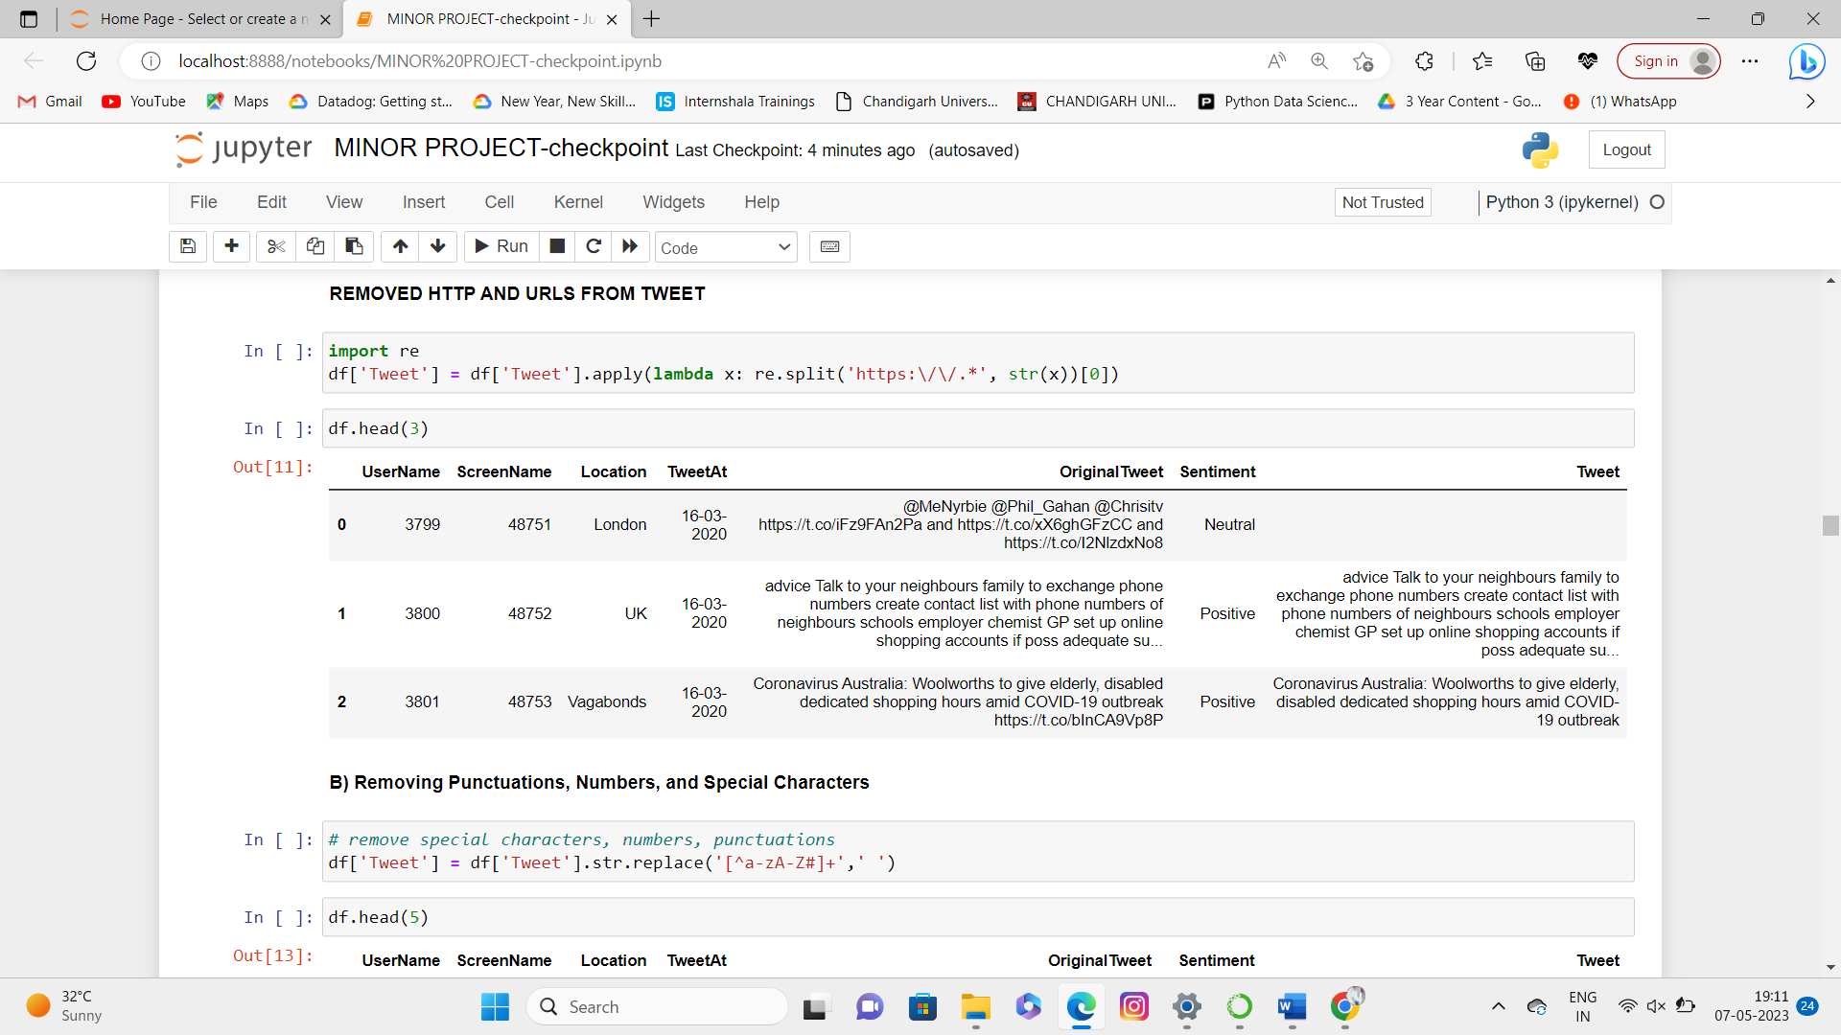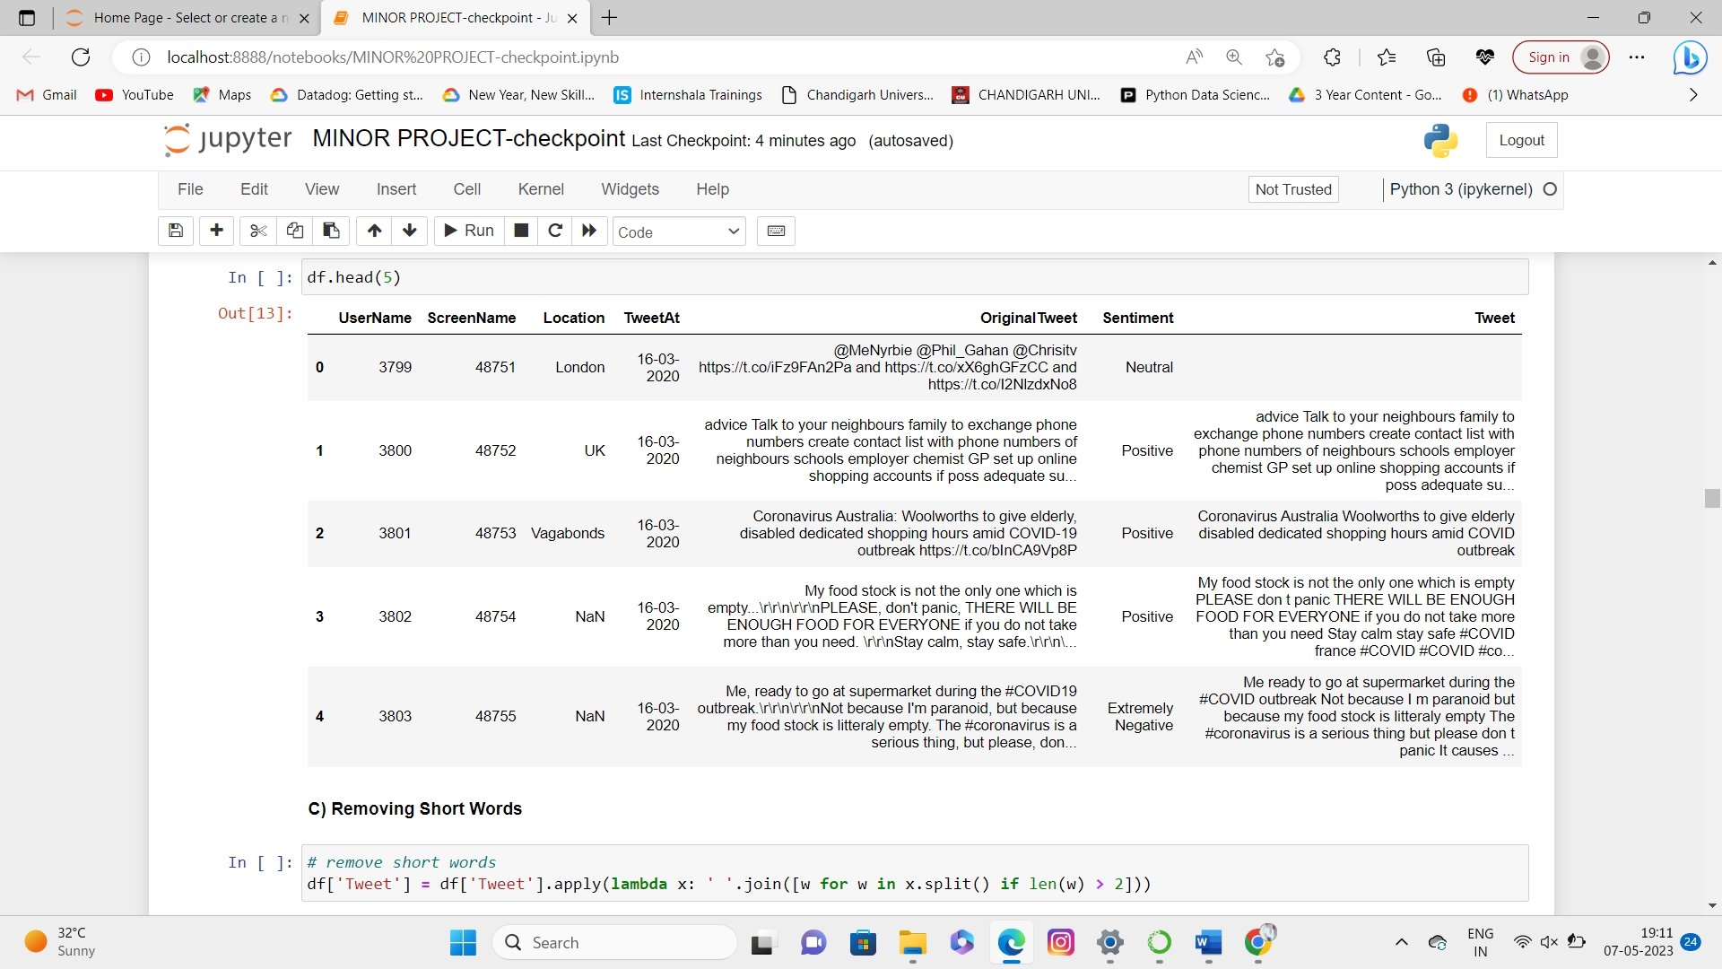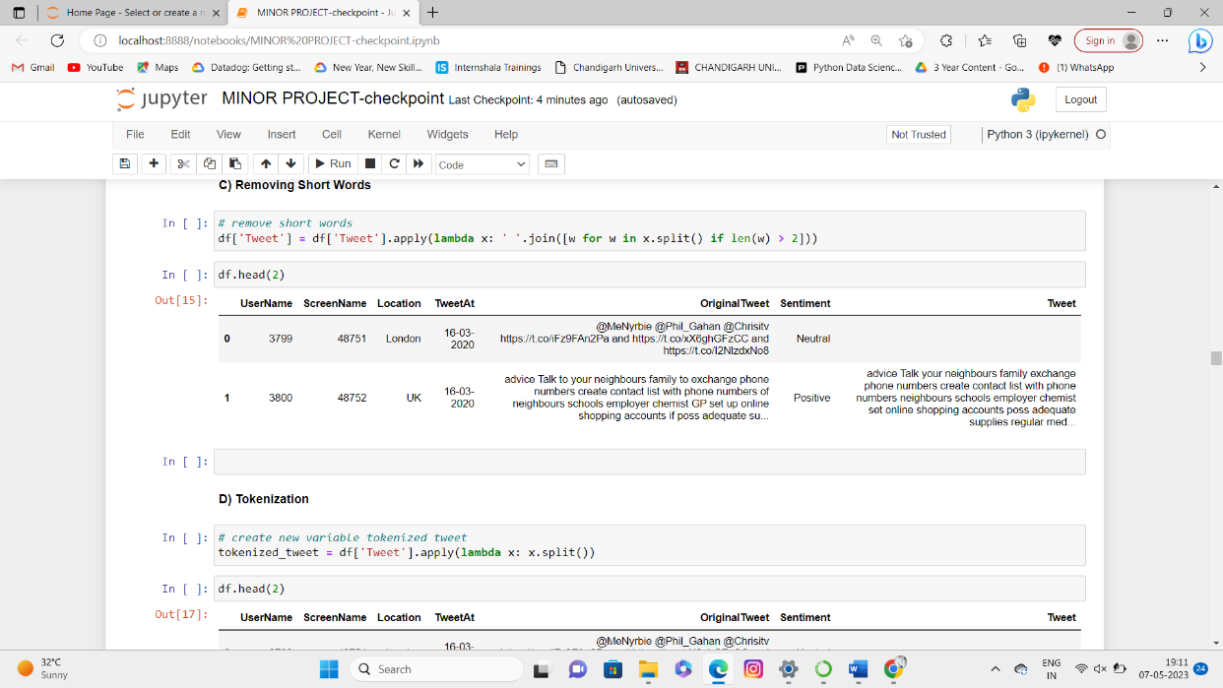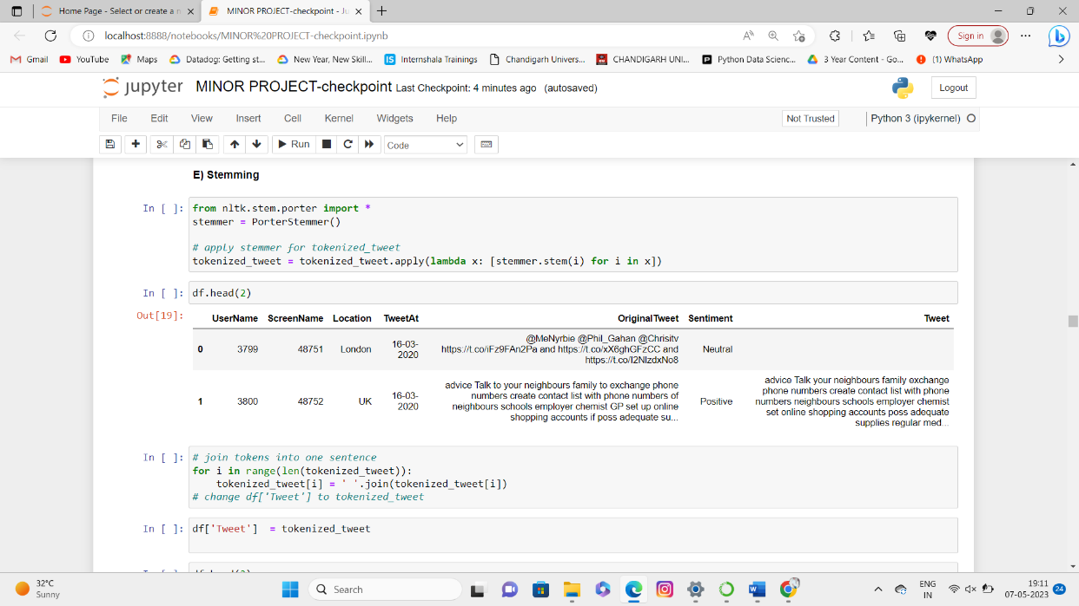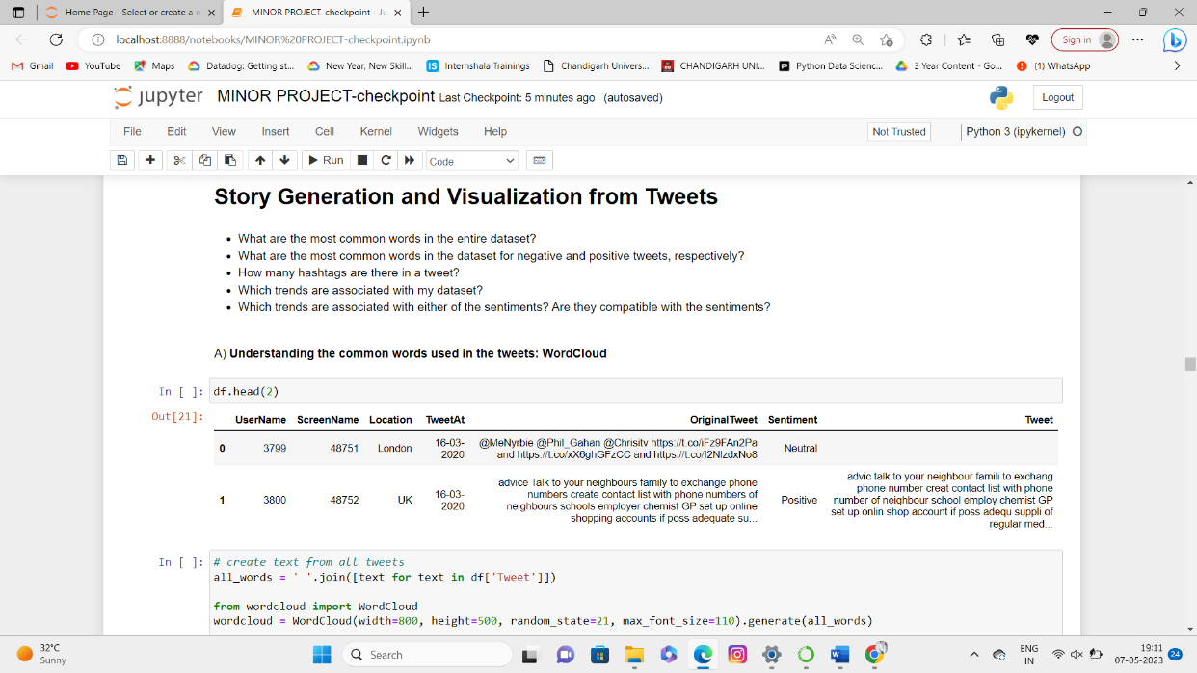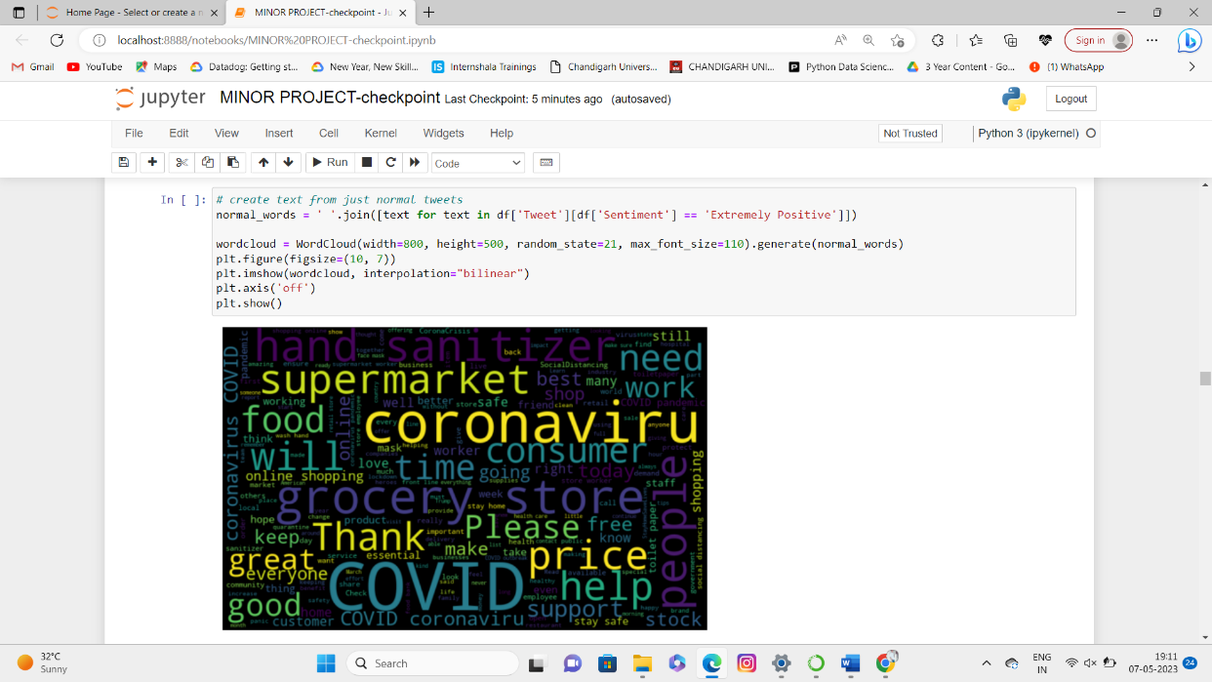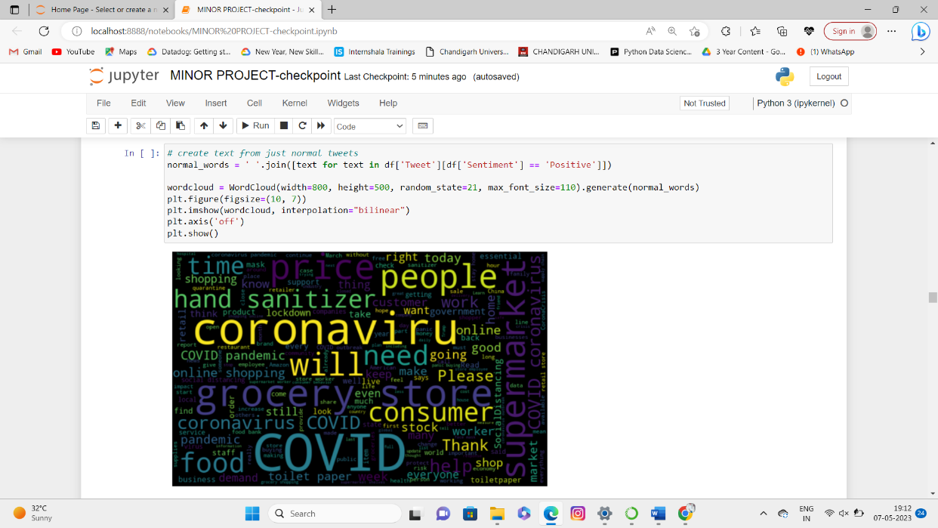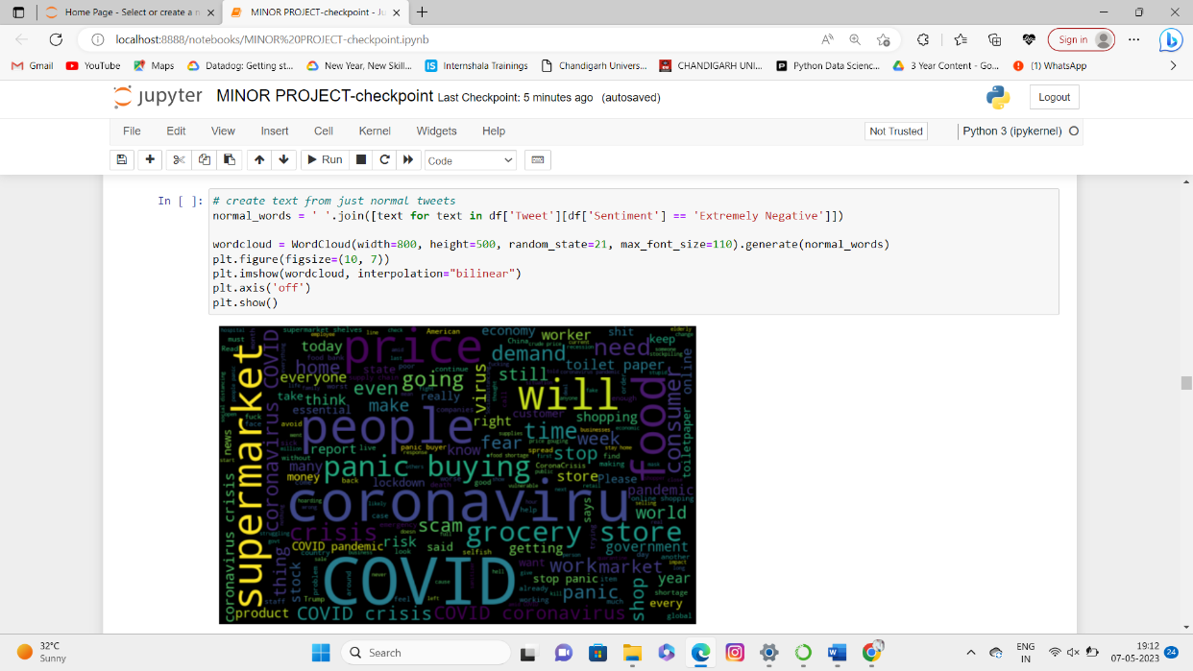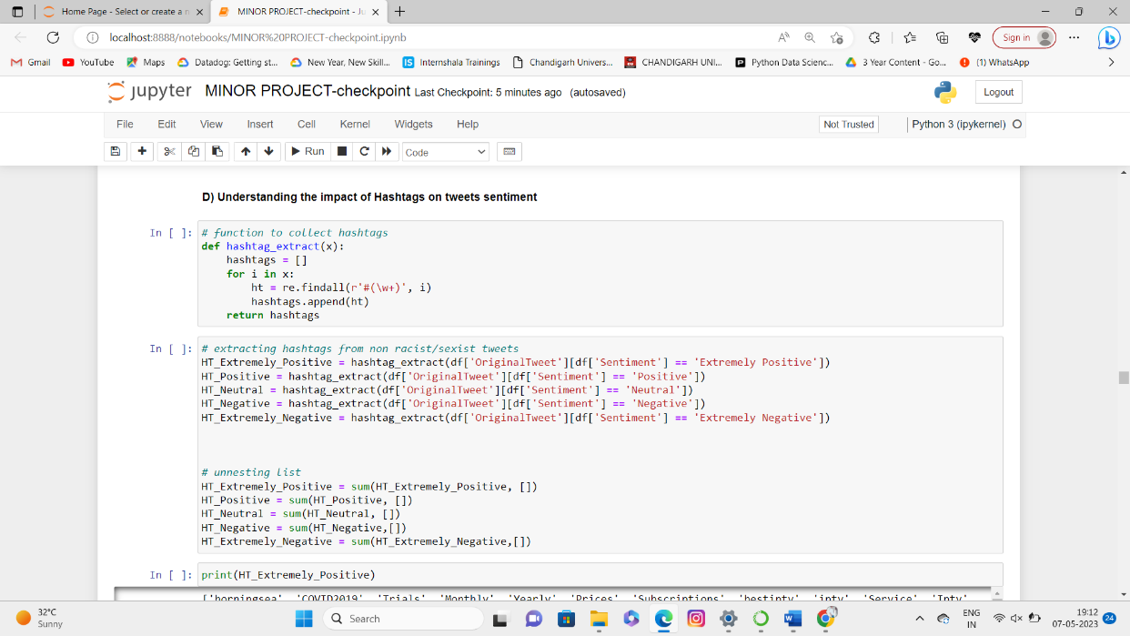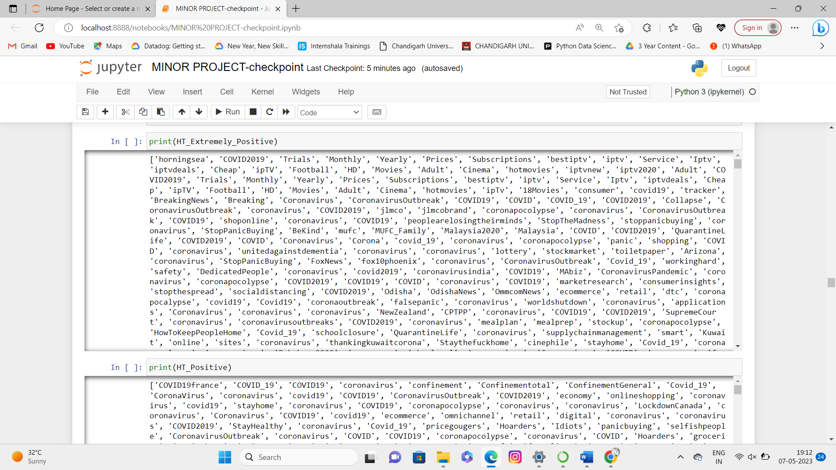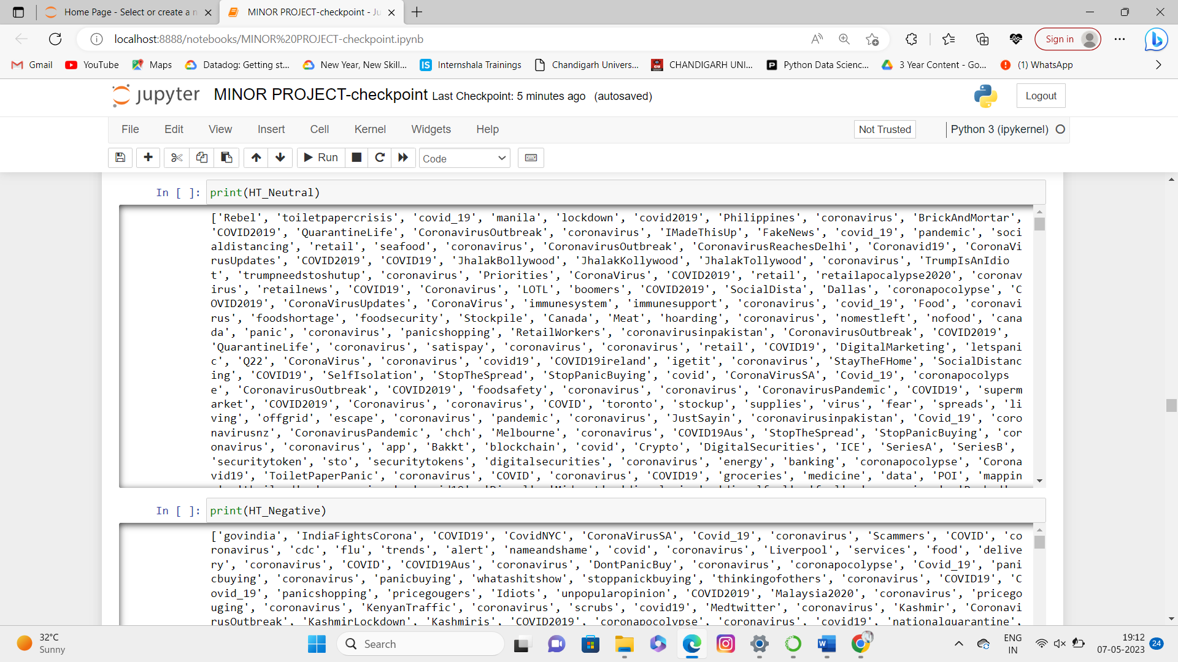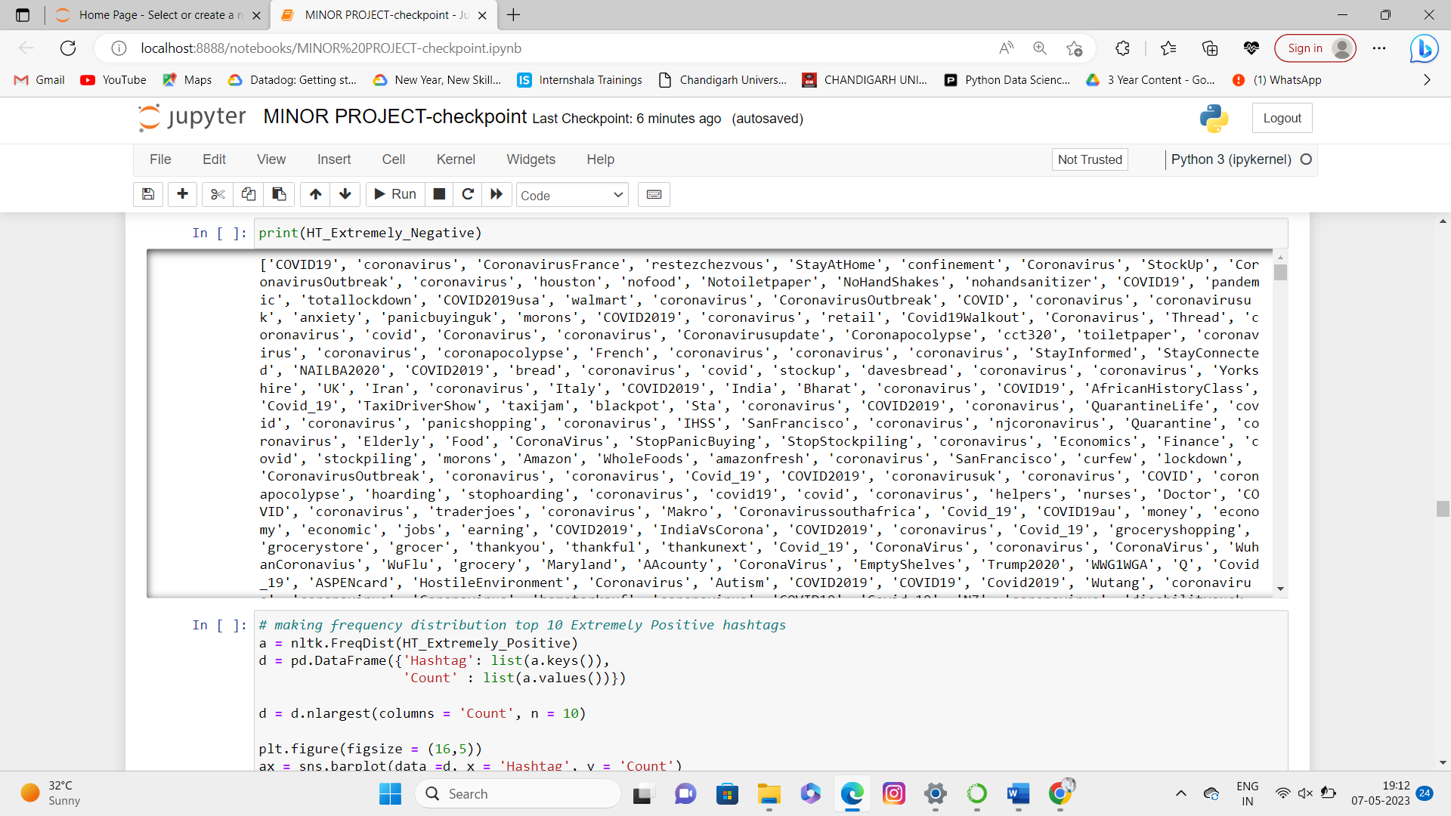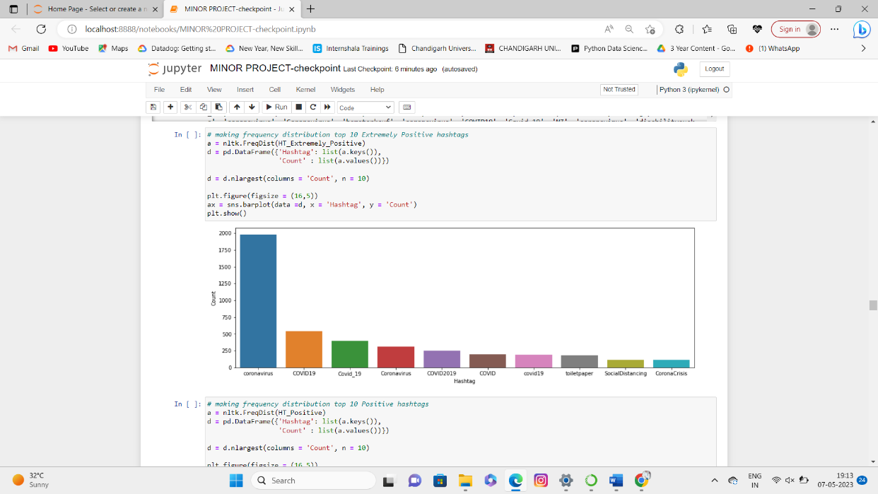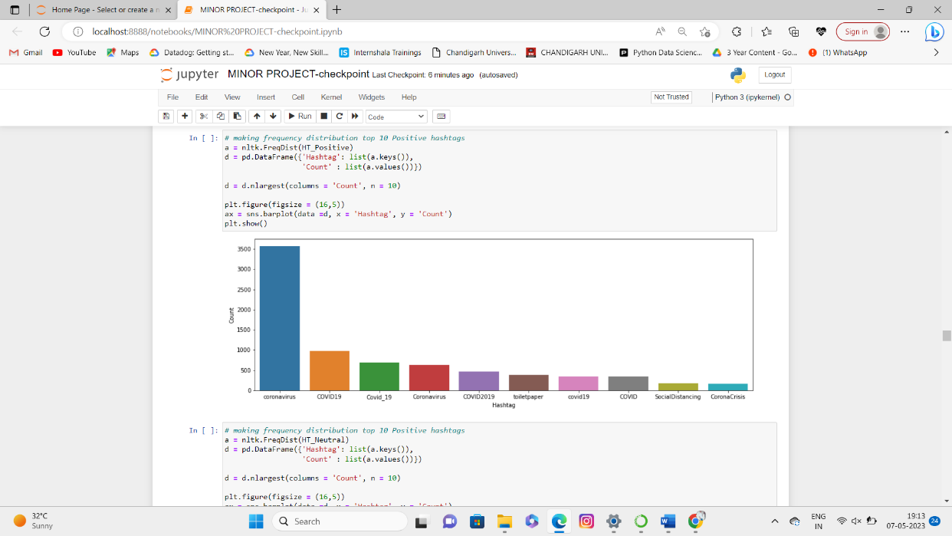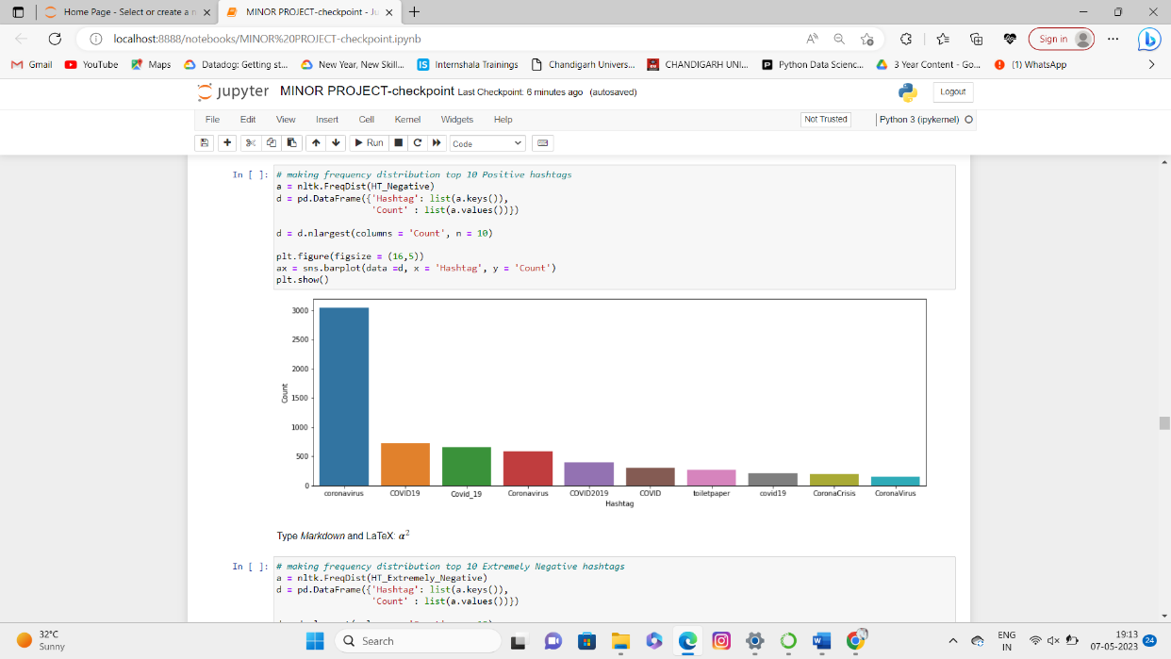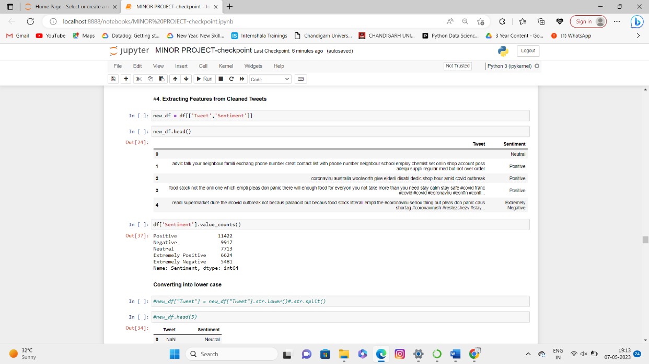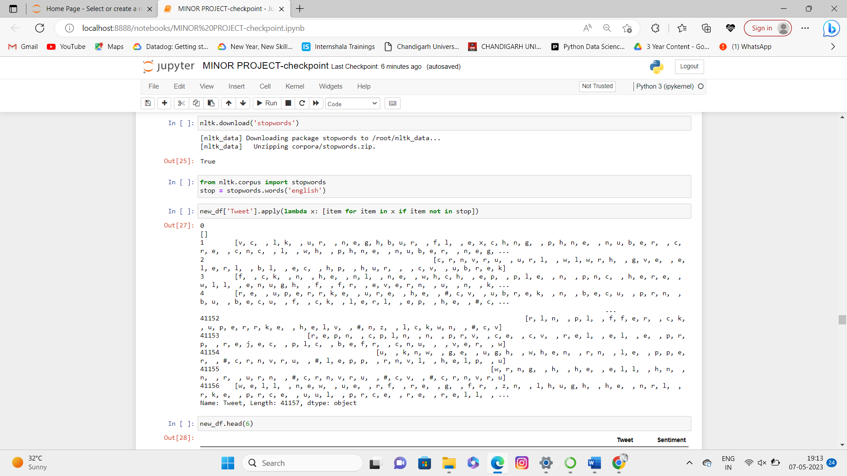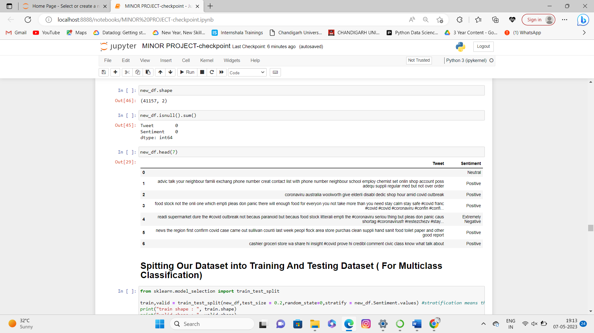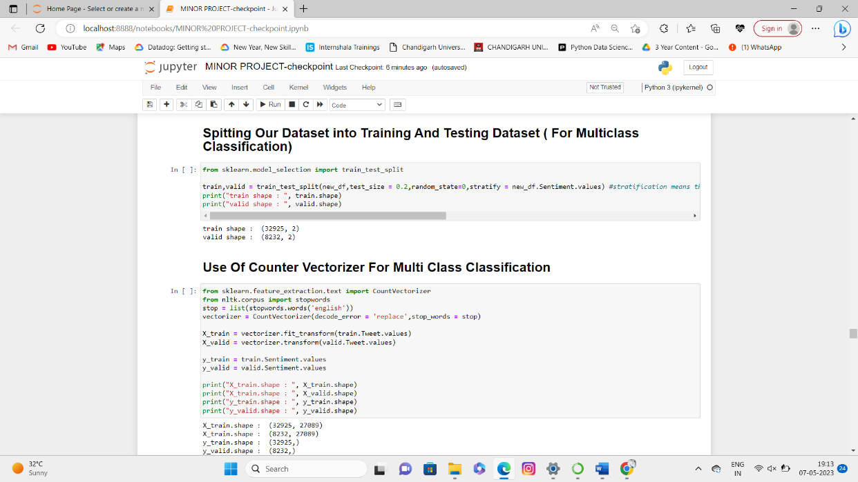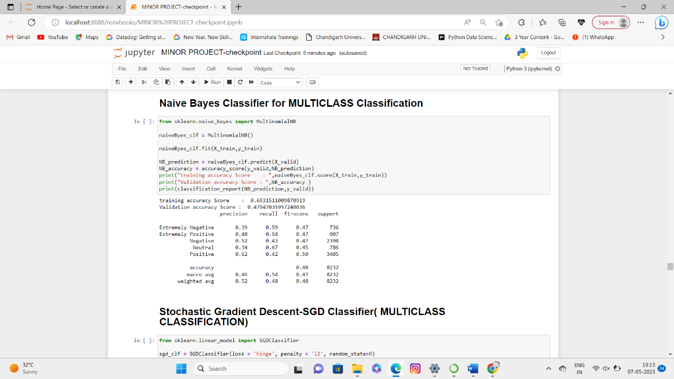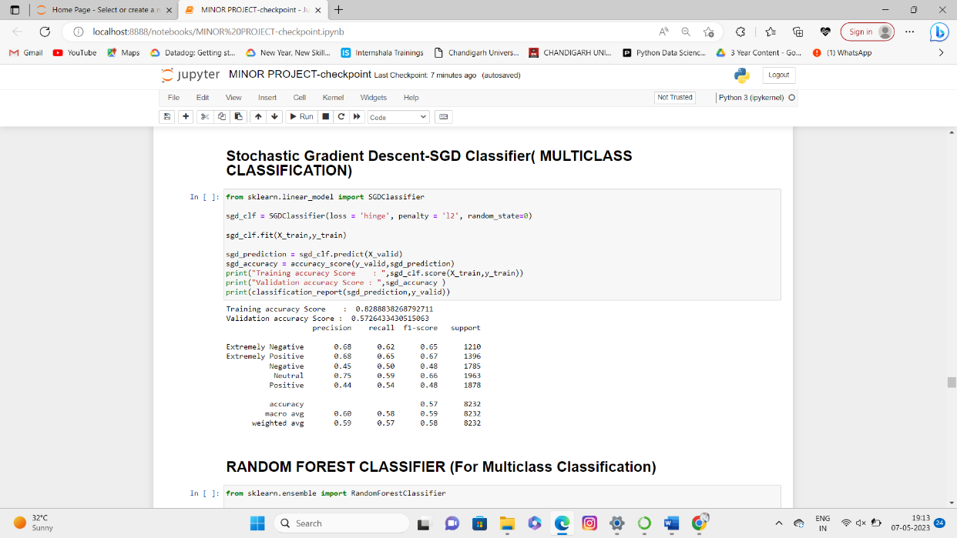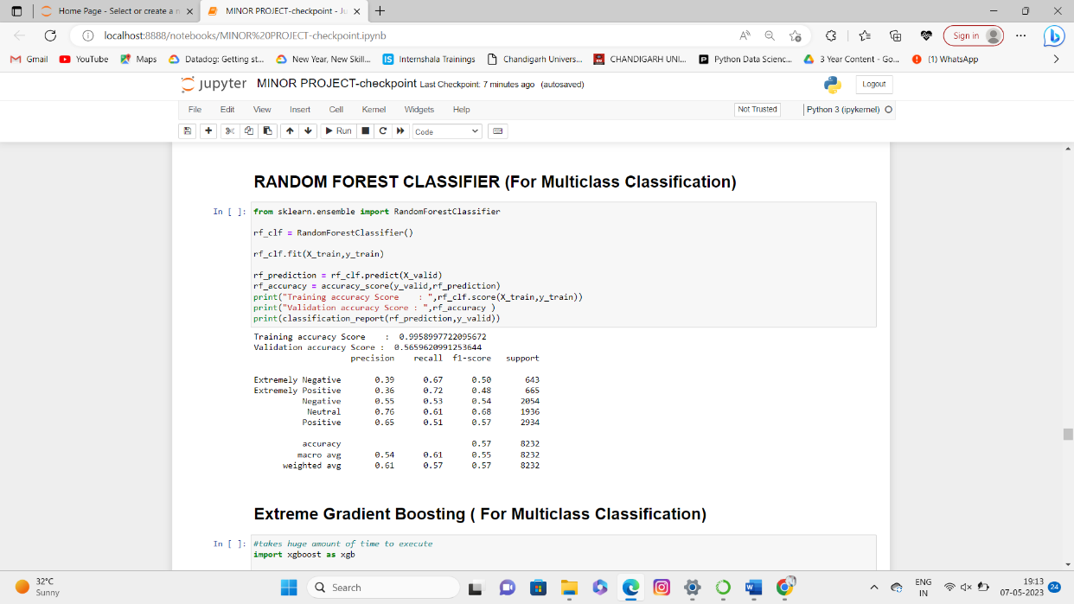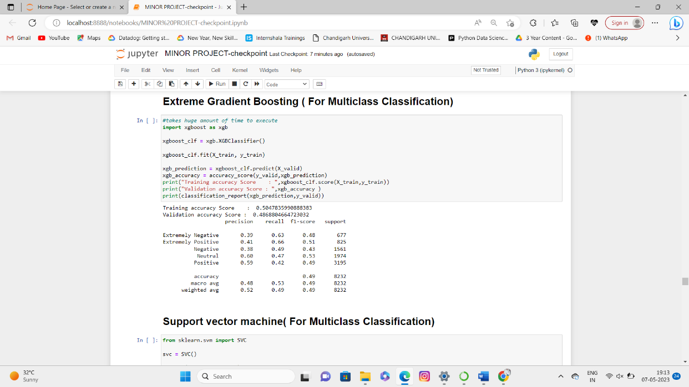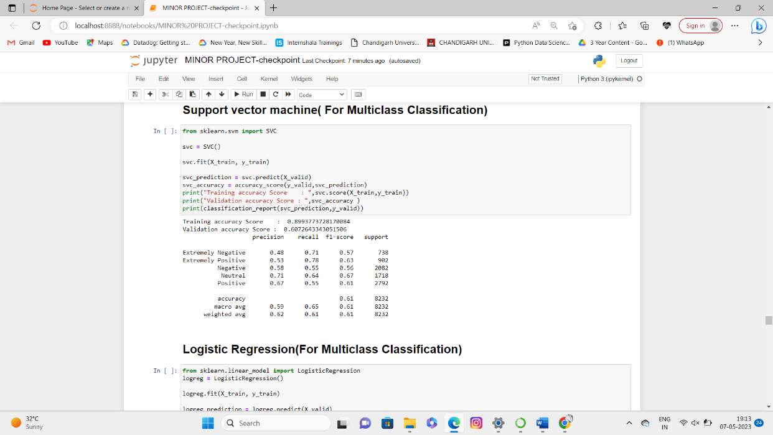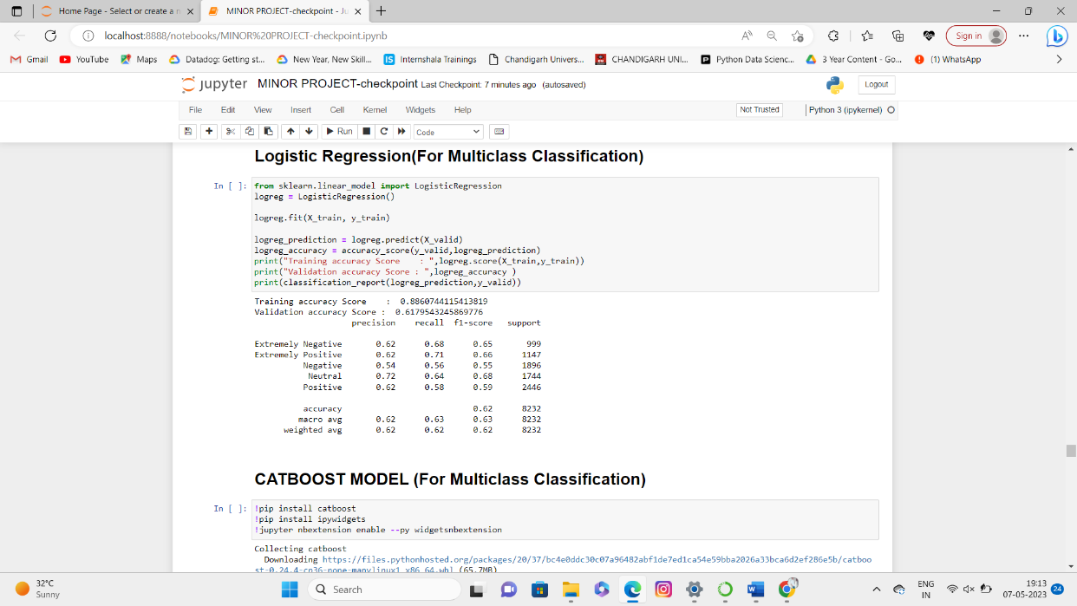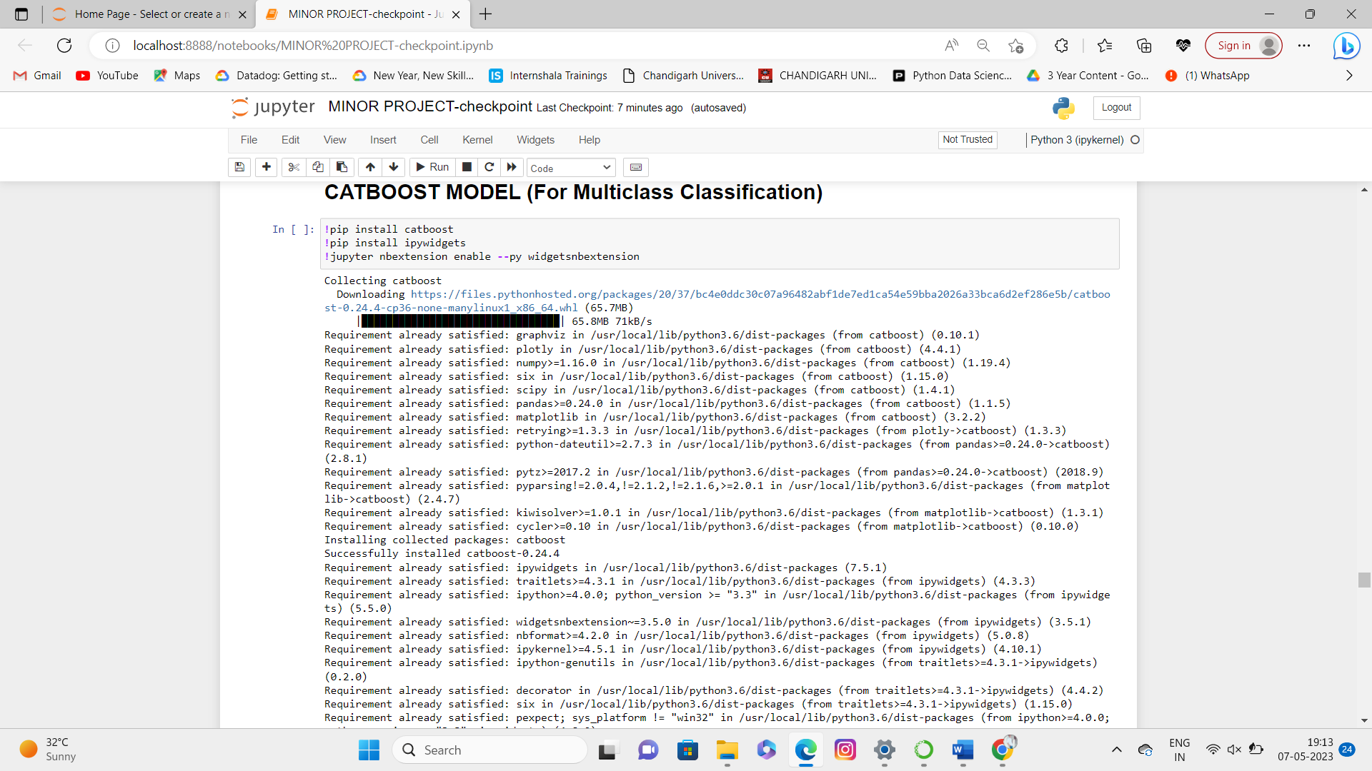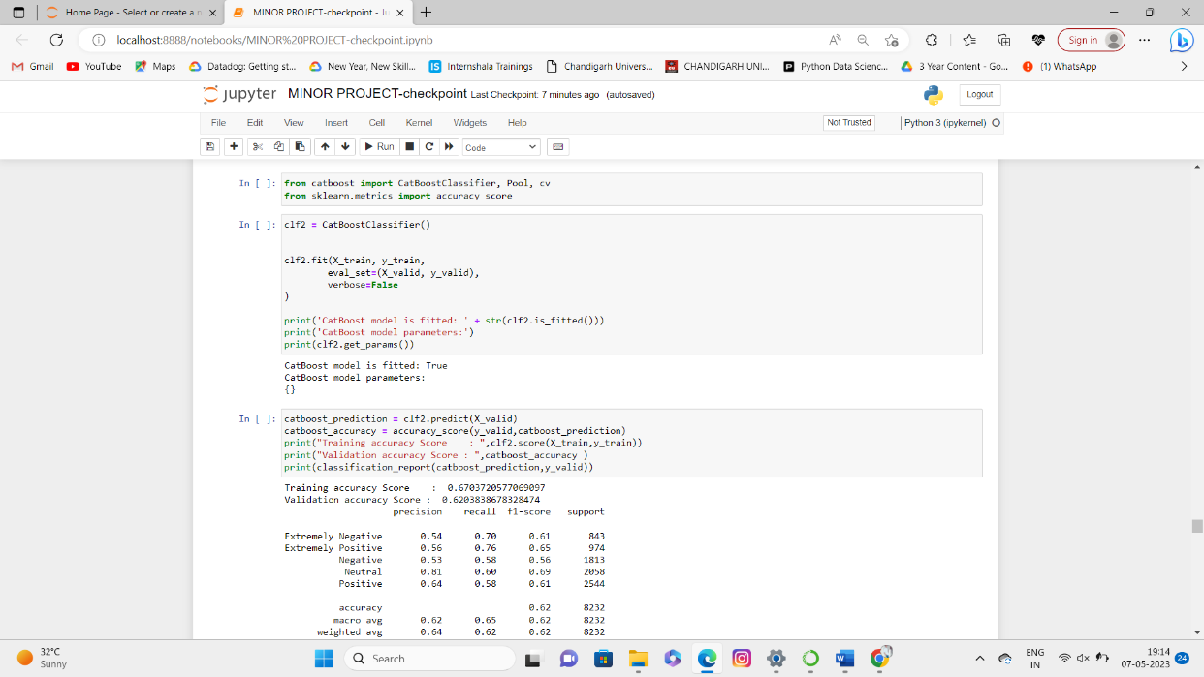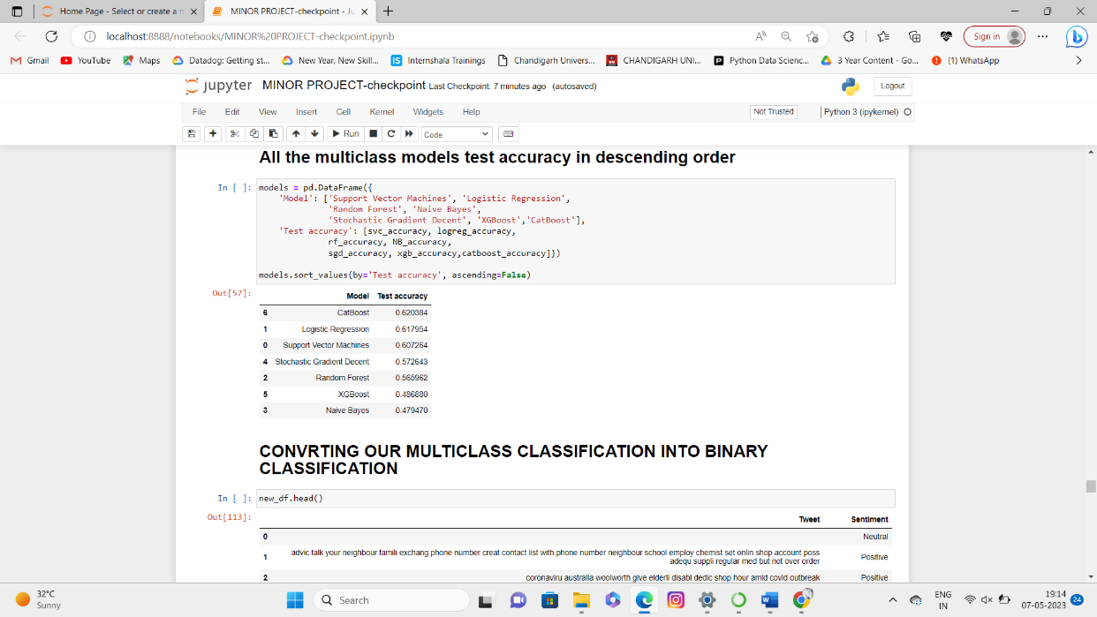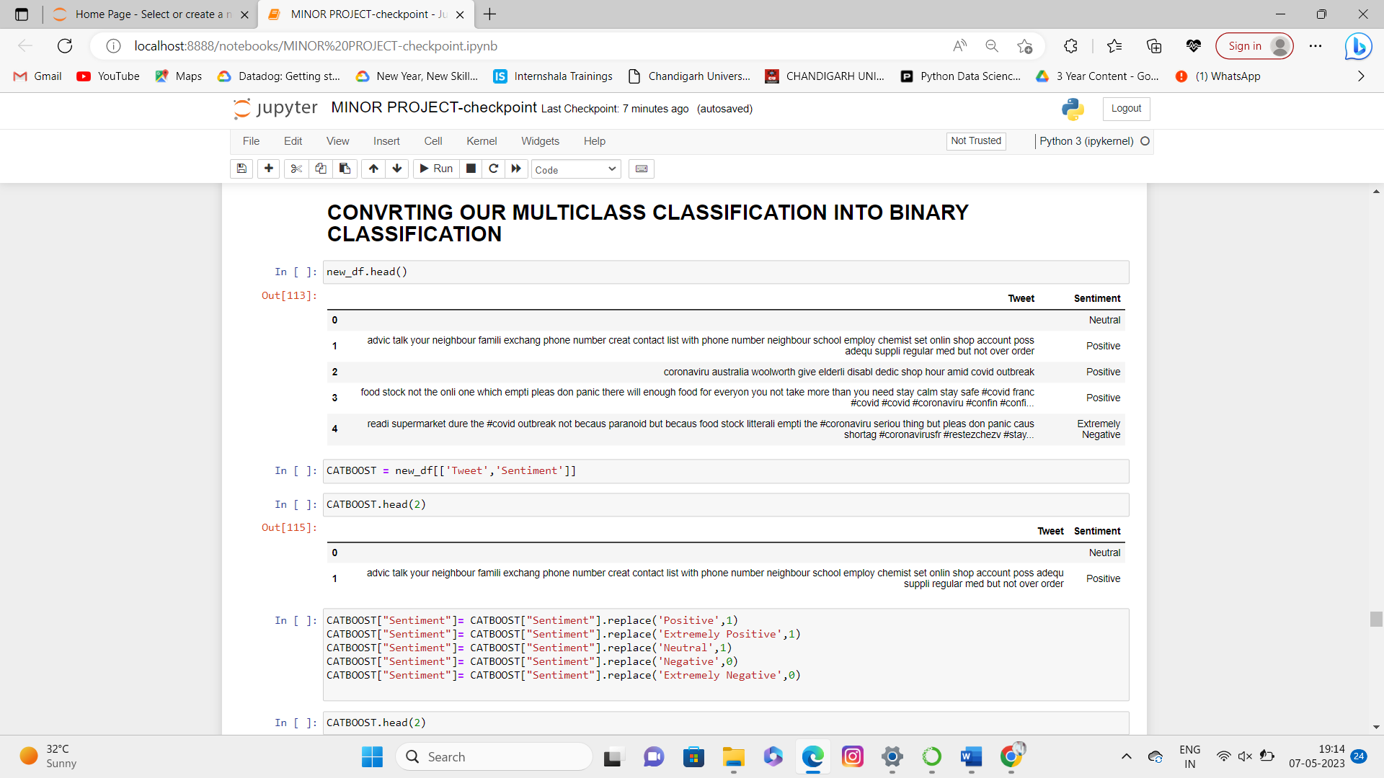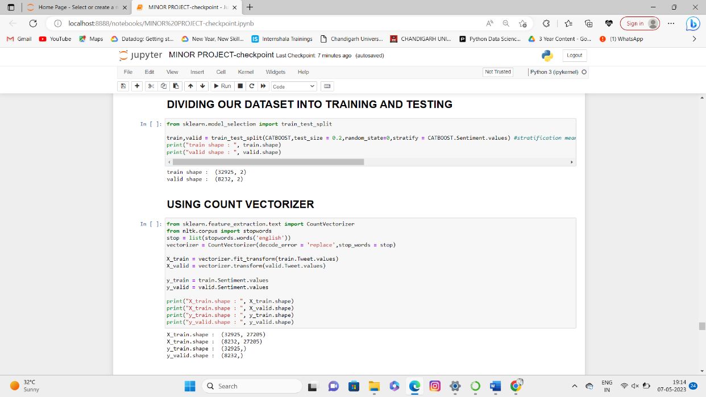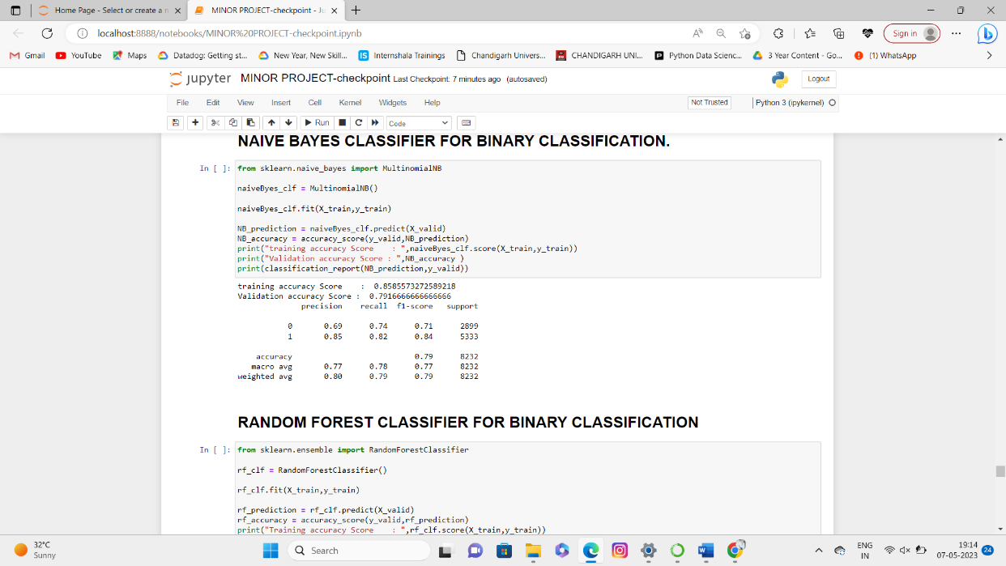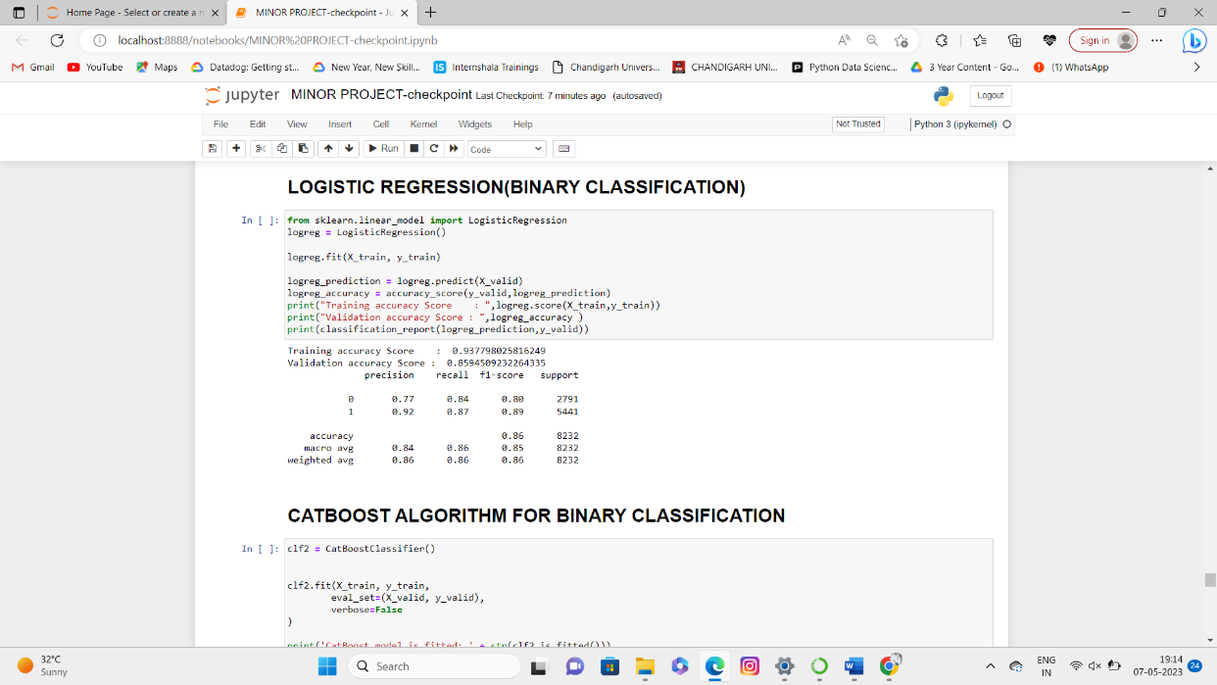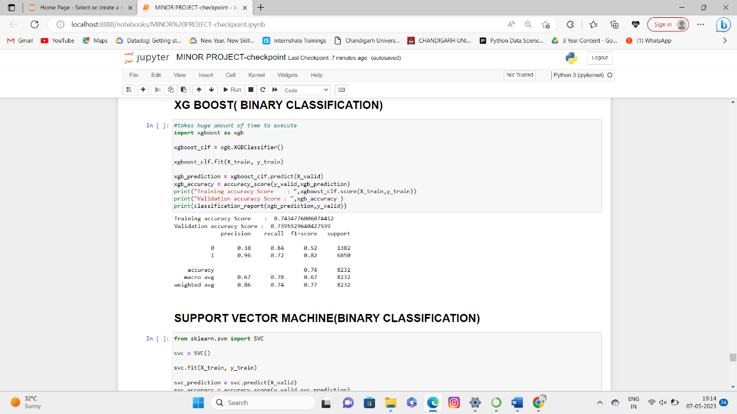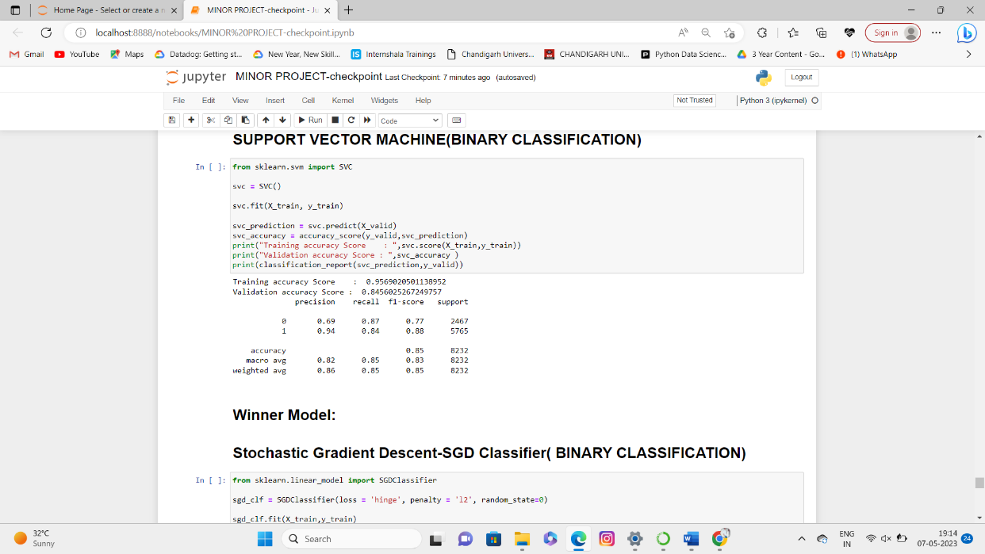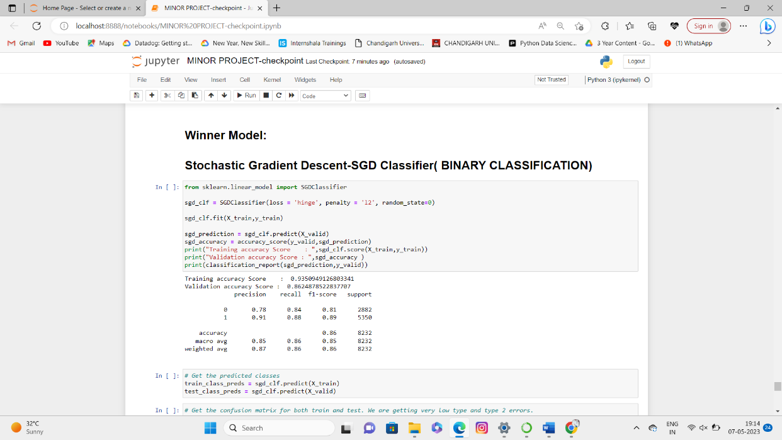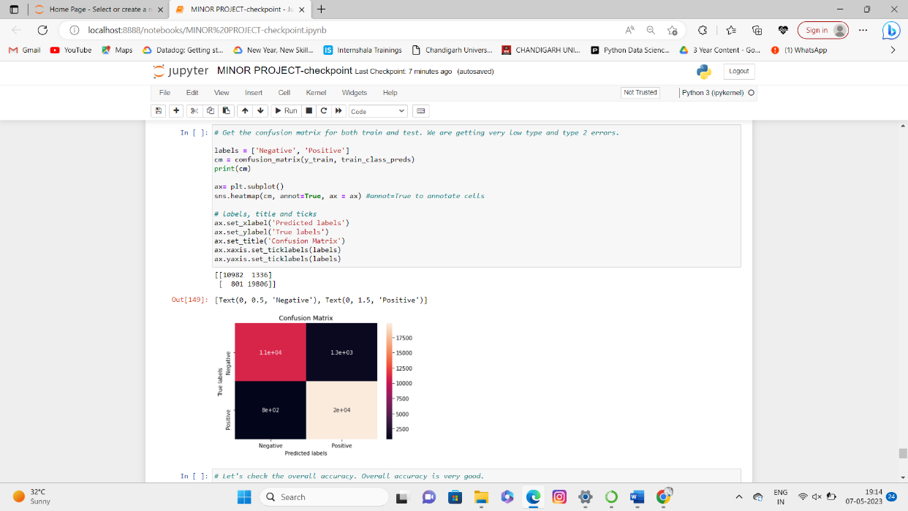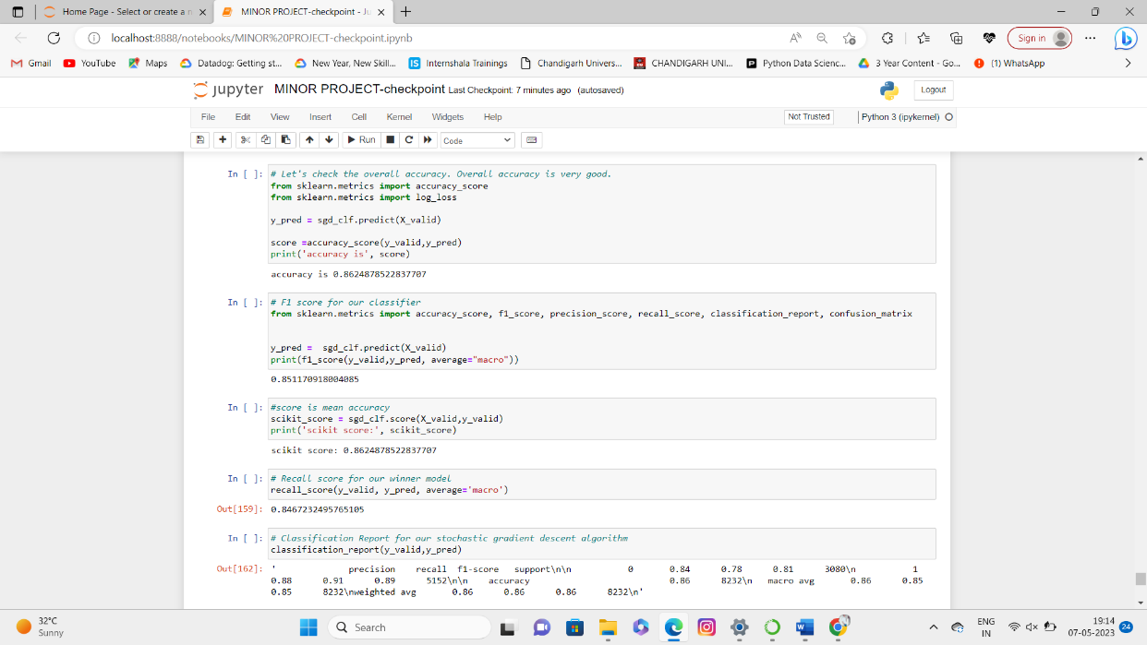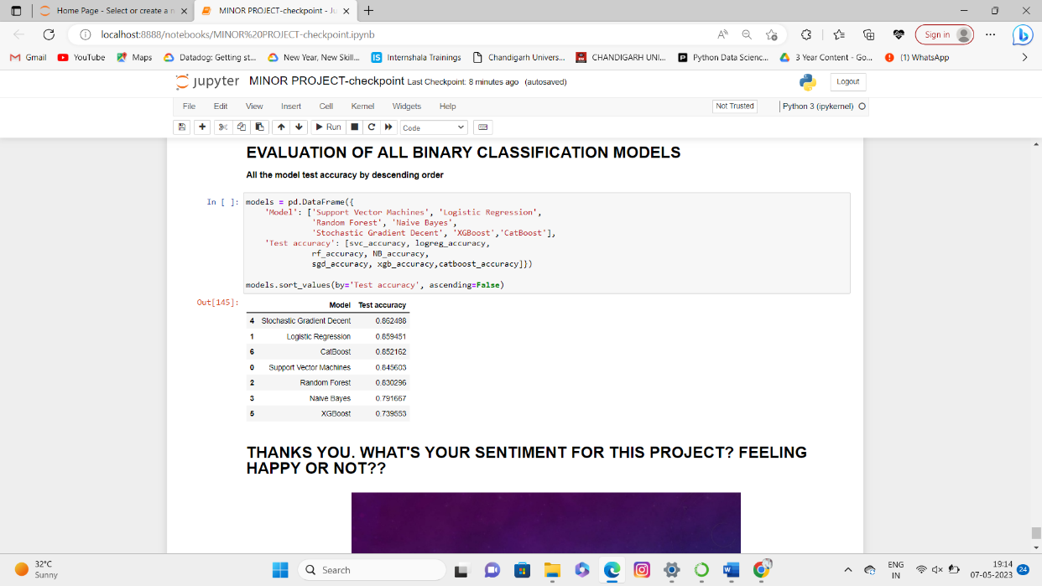

# 7.1. CONCLUSION

In conclusion, an optimized artificial intelligence enabled sentiment analysis on the COVID-19 pandemic has proven to be a powerful tool in understanding the emotions, opinions, and attitudes of people towards this global crisis. By using advanced machine learning algorithms, natural language processing techniques, and big data analytics, AI-based sentiment analysis can effectively analyze millions of social media posts, news articles, and online discussions in real-time to provide valuable insights to public health officials, policymakers, and businesses.

The sentiment analysis results can help identify the key concerns and issues related to the pandemic, track the spread of misinformation and conspiracy theories, monitor public sentiment towards government responses and policies, and provide early warnings of potential social unrest or public health crises. Additionally, AI-enabled sentiment analysis can help improve crisis communication strategies by identifying the most effective messaging and communication channels for different target groups.

However, there are also limitations and ethical considerations to be taken into account, such as the risk of bias and privacy concerns related to the use of personal data. Therefore, it is essential to develop transparent and accountable AI models and frameworks that prioritize data privacy, security, and fairness.

Overall, AI-enabled sentiment analysis holds enormous potential in providing real-time insights and support for decision-making during public health crises such as the COVID-19 pandemic, but it is important to ensure that its development and application are guided by ethical principles and human-centered values.

**7.2. FUTURE SCOPE**

The future scope of an optimized Artificial Intelligence (AI) enabled sentiment analysis on the COVID-19 pandemic includes:

Enhanced accuracy: Continued improvements in AI algorithms and models can lead to higher accuracy in sentiment analysis. This can help in better understanding and capturing the nuances of human emotions and opinions related to the pandemic.

Real-time monitoring: AI-enabled sentiment analysis can be used for real-time monitoring of public sentiment during the ongoing COVID-19 pandemic. This can assist in detecting emerging trends, identifying areas of concern, and enabling timely responses from authorities.

Multilingual analysis: Expanding sentiment analysis to multiple languages can provide a more comprehensive understanding of global sentiment towards the pandemic. This can help in identifying regional variations and tailoring appropriate responses based on cultural and linguistic contexts.

Real-time monitoring: AI-enabled sentiment analysis can be used for real-time monitoring of public sentiment during the ongoing COVID-19 pandemic. This can assist in detecting emerging trends, identifying areas of concern, and enabling timely responses from authorities.

Psychological analysis: AI-enabled sentiment analysis can be combined with psychological analysis techniques to gain deeper insights into the emotional and mental well-being of individuals during the pandemic. This can aid in the development of targeted interventions and mental health support systems.

Sector-specific sentiment analysis: Adapting sentiment analysis techniques to different sectors (e.g., healthcare, education, economy) can provide sector-specific insights into the impact of the pandemic. This can aid in developing tailored strategies and policies to address the unique challenges faced by each sector.

Ethical considerations: As sentiment analysis becomes more pervasive, addressing ethical concerns such as privacy, bias, and transparency will be crucial. Future developments should focus on ensuring fairness, accountability, and user consent in AI-enabled sentiment analysis systems.

Overall, the future scope of an optimized AI-enabled sentiment analysis on the COVID-19 pandemic encompasses improved accuracy, real-time monitoring, multilingual analysis, social media impact analysis, psychological analysis, predictive analytics, sector-specific analysis, risk assessment, long-term impact assessment, and ethical considerations.

## 8. TENTATIVE CHAPTER PLAN FOR THE PROPOSED WORK

**CHAPTER 1: INTRODUCTION AND PROBLEM DEFINITION**

This chapter covers the overview of project “An optimized Artificial Intelligence enabled Sentiment Analysis on COVID-19 Pandemic”

**CHAPTER 2: LITERATURE REVIEW**

This chapter includes the literature available for the project work. The findings of the researchers are highlighted which is the basis of the current implementation.

**CHAPTER 3: PROBLEM FORMULATION**

This chapter provides introduction to the concepts which are necessary to understand the proposed system.

**CHAPTER 4: OBJECTIVES**

This chapter covers the technical details of the proposed approach.

**CHAPTER 5: METHODOLOGIES**

This chapter provides information about the subject system and tools used for evaluation of proposed methods.

**CHAPTER 6: EXPERIMENTAL SETUP**

Here we mentioned the code and results obtained.

**CHAPTER 7:** **CONCLUSION AND FUTURE SCOPE**

The future scope of an optimized AI-enabled sentiment analysis on the COVID-19 pandemic encompasses improved accuracy, real-time monitoring, multilingual analysis, social media impact analysis, psychological analysis, predictive analytics, sector-specific analysis, risk assessment, long-term impact assessment, and ethical considerations.

## REFERENCES

1. Li, Y., Chen, L., Li, S., & Li, Y. (2021). An Optimized Sentiment Analysis Method for COVID-19 Pandemic Based on Improved Neural Network Algorithm. IEEE Access, 9, 33036-33047.
2. Abbasi, A., & Khalid, S. (2020). Sentiment Analysis and Visualization of COVID-19 Tweets Using Deep Learning. Information, 11(6), 314.
3. Loukoumis, E., Wilson, T., & Moore, J. D. (2011). Twitter sentiment analysis: The good the bad and the OMG!. ICWSM, 11(538-541), 164.
4. Zhao, Y., Mao, Y., & Chen, Y. (2020). A study of sentiment analysis of COVID-19 pandemic in Wuhan social media using machine learning. Journal of Healthcare Engineering, 2020, 1-7.
5. Zhang, L., Zhou, Y., & Fung, P. (2020). An optimized sentiment analysis method for COVID-19 pandemic based on deep learning. Journal of Biomedical Informatics, 111, 103619.